

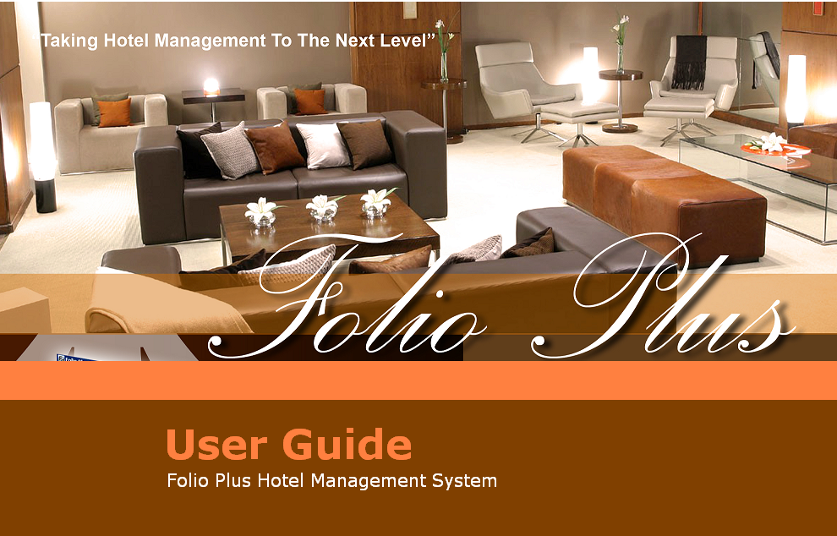

FOLIO PLUS
Professional Edition

Version 3.0.0
JANUARY 2010
Version Released:
NOVEMBER 2008
JINISYS Software, Inc.

Folio Plus Professional Edition
Version 3.0.0

Table of Contents

Table of Contents 2

LIABILITY DISCLAIMER 6

INTRODUCTION 7

I. THE FOLIO PLUS ENVIRONMENT 8

LOG-IN Screen 8
MAIN Screen 8
Title Bar 8
Menu Bar 9
Tool Bar 9
System Audit Date/Time 9
Hotel Logo 9
Today's Room Status 10
Today's Room Status Summary 10
Occupancy Rate 10
Status Bar 10
Working Area 10

II. HOTEL CONFIGURATION 11

- Hotel Information 11
Insert a New Hotel …......12
Edit Information of a Hotel 12
Delete a Hotel 12
- Departments 13
Insert a New Department 14
Edit Information of a Department 14
Delete a Department 14
- Floor Plan 15
Insert a New Floor Level 15
Edit Information of a Floor Level 16
Delete a Floor Level 16
- Currency 17
Insert a New Currency 18
Edit Information of a Currency 18
Delete a Currency 18
- Room Types 19
Insert a New Room Type 20
Edit Information of a Room Type 20
Delete a Room Type 20
- Room Amenities 21
Insert a New Amenity 21
Edit Information of an Amenity 22
Delete an Amenity 22
- Rooms 22
Insert a New Room 23
Edit Information of a Room 24
Delete a Room 24
Plot a Room's Coordinate 24
- Rate Codes 25
Insert a New Rate Code 25
Edit Information of a Rate Code 26
Delete a Rate Code 26
- Rate Types 26
Insert a New Rate Type 27
Edit Information of a Rate Type 27
Delete a Rate Type 28
- Transaction Types 28
Insert a New Transaction Type 29
Edit Information of a Transaction Type 29
Delete a Transaction Type 29
- Transaction Source Documents 30
Insert a New Transaction Source Document 30
Edit Information of a Transaction Source Document 31
Delete a Transaction Source Document 31
- Transaction Codes 32
Insert a New Transaction Code 33
Edit Information of a Transaction Code 33
Delete a Transaction Code 34
- Transaction Code Sub-Accounts 34
Insert a New Transaction Code Sub-Account 35
Edit Information of a Transaction Code Sub-Account 36
Delete a Transaction Code Sub-Account 36
- Event Requirements 36
Insert a New Event Requirement 37
Add/Remove Requirement Detail 37
Edit Information of an Event Requirement 38
Delete an Event Requirement 38
- Event Types 39
Insert a New Event Type 40
Add/Edit Event Detail 40
Edit Information of an Event Type 40
Delete an Event Type 41
- Event Packages 41
Insert a New Event Package 42
Add/Remove Package Requirement 42
Add/Remove Charges 43
Edit Information of Event Package 43
Delete an Event Package 43
- Event Applied Rates 44
Insert a New Event Applied Rate 45
Edit Information of an Event Applied Rate 45
Delete an Event Applied Rate 45
- Meal Groups 46
Insert a New Meal Group 46
Edit Information of a Meal Group 47
Delete a Meal Group 47
- Meal Items 48
Insert a New Meal Item 49
Edit Information of a Meal Item 49
Delete a Meal Item 49

- Meal Menus 50
Insert a New Meal Menu 51
Edit Information of a Meal Menu 51
Add/Remove Meal Item 51
Delete a Meal Menu 51
- Engineering Services 52
Insert a New Engineering Service 53
Edit Information of an Engineering Service 53
Delete an Engineering Service 53
- Privileges 54
Insert New Privilege 55
Edit Information of a Privilege 55
Delete a Privilege 56
- Hotel Promos 56
Insert a New Hotel Promo 57
Edit Information of a Promo 58
Delete a Promo 58
- Housekeepers 58
Insert a New Housekeeper 59
Edit Information of a Housekeeper 59
Delete a Housekeeper 60
- Taxi Drivers 60
Insert a New Taxi Driver 61
Edit Information of a Taxi Driver 61
Delete a Taxi Driver 62
- Individual Guests 62
Insert a New Individual Guest Account 63
Add/Remove Privilege 64
Edit Information of an Individual Guest Account 64
Delete an Individual Guest Account 65
- Group Guests 65
Insert a New Company Account 67
Add/Remove Privilege 67
Edit Information of a Company Account 68
Delete a Company Account 68
- User Roles 68
Insert a New User Role 69
Edit Information of a User Role 69
Delete a User Role 69
- System Users 70
Insert a New User Account 71
Add/Remove Roles 71
Reset Password of User 71
Edit Information of a User Account 71
Delete a User Account 72
- System Configuration 72
Edit Information of System Configuration 72

III. BASIC TRANSACTIONS 73

- Check-In through Walk-In. 73
- Check-In through Reservation 73
- Single Reservation 74
Add a Room Schedule 76
Add/Remove Recurring Charges 79
Add/Remove Promos 80
Add/Remove Privileges 81
Add Guest Information 82
Add/Remove Joiners 83
- Group Reservation 84
Add Booking Information 85
Add/Remove Function Schedules 85
Block Room Requirements 86
Add/Remove Billing Information 86
Add Hotel Package 87
Add Event Details 87
Add Food & Beverage 87
Add Reservation Information on Child Folios 88
Add Privileges 88
Apply Hotel Promos 89
Add Amendment 89
- Guest List 90
Search for a Guest 91
Make a Reservation 91
Cancel a Reservation 92
- Folio Ledgers List 94
- Folio Ledger 95
Insert Transaction (Charges/Payments) 96
Void Transaction 97
Recall Voided Transaction 98
Transfer Debit/Credit 98
- Check-Out Folio 100
- Routing Transaction 102
- Direct Transaction Posting 103
Charge & Payment Transaction 104
Driver's Commission 104
Disbursement 105
Void Transaction 105
- Opening/Closing Shift 106
Open Cash Drawer 106
Close Cash Drawer 107
- Day-End Closing 108
Process Night Audit 108

LIABILITY DISCLAIMER

JINISYS Software, Incorporated has prepared this document for use by its employees and clients. The information contained herein is the property of JINISYS Software, Incorporated and shall not be reproduced without prior written approval from JINISYS Software, Incorporated.

JINISYS Software, Incorporated reserves the right to change the specifications and functions at any time without notice.

Conventions used:

> Denotes a Sub-menu
Denotes a Tip

? Denotes a Frequently Asked Question (FAQ)

INTRODUCTION

What is Folio Plus Hotel Management System?

Folio Plus is software designed to make hotel service more efficient while making the tasks of the hotel staff easier, enabling them to be more productive. The system provides the hotel with the capability to retain information of all its patrons through its Intellisense. Additionally, it protects the system data and functions with its tight security measures. Thus, with Folio Plus, your clientele feels valued and personnel performance significantly improves as it takes hotel management to the next level.

I. THE FOLIO PLUS ENVIRONMENT

LOG-IN Screen
TO LOG IN:

Enter your user name and password.
Click on Ok button to proceed to the Main Screen.
Click on Cancel button to close the application.

Note: The user name and password fields are case sensitive.

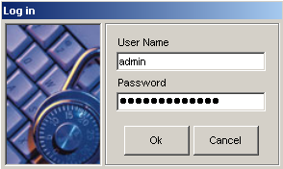
1

2

Figure I-1

- User Name field – this is where the current user inputs his/her user name.
- Password field – this is where the current user inputs his/her password.
1

2

3

MAIN Screen
4

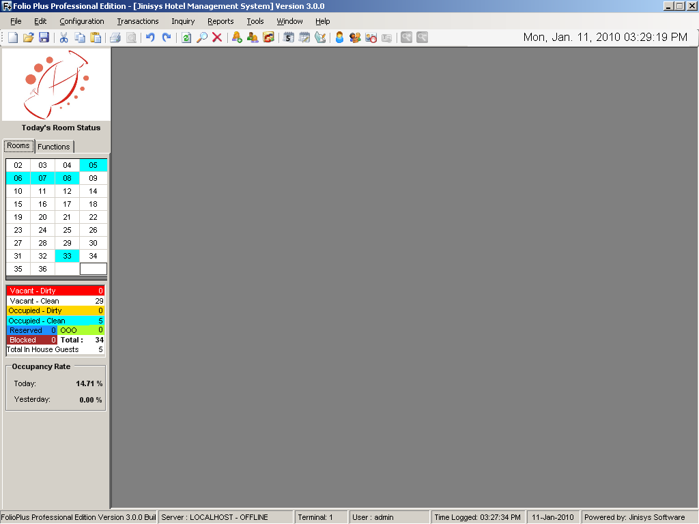
3

5

6

7

8

10

9

Figure I-2

- Title Bar – displays the title of the application, hotel name and Folio Plus Version.

Figure I-3

- Menu Bar – holds all system menus (e.g. File, Edit, etc.) that contain the functions of the software.

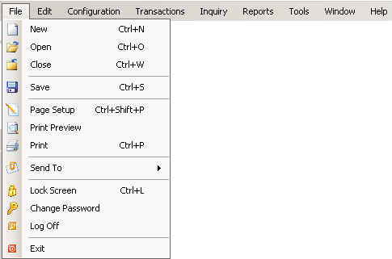

Figure I-4

- Navigation Tool Bar – holds all shortcut buttons for faster access of functions; the button name is shown when the mouse points to it.

Figure I-5

- System Audit Date/Time – displays audit date of the system; audit date may not coincide with the actual date.

Figure I-6

- Hotel Logo – displays the hotel logo. This logo is also seen in every hotel report.


Figure I-7

- Today’s Room Status – shows the status of each room through color codes (e.g. Turquoise for Occupied-Clean).
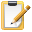
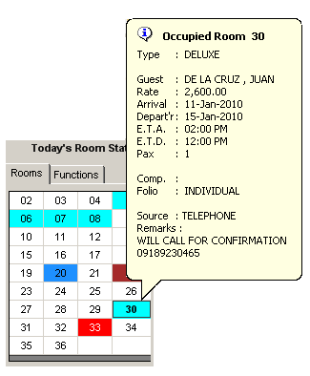

Do you know that…

You can view a guest’s basic information by just pointing your mouse to the Room no. he/she is occupying.

You can use Today’s Room Status to check in Walk-In guests. Just double-click a Room No. and the Reservation screen will open.

You can go directly to a guest’s folio, check-out window, etc. by right clicking on the guest’s Room No. and selecting the desired option.

Figure I-8

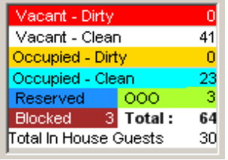
- Today’s Room Status Summary – displays a summary of the Current Day’s Room Status (Figure I-8).

Figure I-9

- Occupancy Rate – displays the Current and Previous Days’ Occupancy Rates.
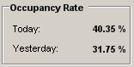

Figure I-10

- Status Bar – displays the Database Server address, Terminal Name, Current logged on user and the time of log, and audit date of the system.

Figure I-11

- Working Area – the Folio Plus working area; houses the corresponding windows for each command or menu accessed.

II. HOTEL CONFIGURATION

- Hotel Information – contains the hotels managed by the software including the general information of the hotels.
Location: Configuration > Hotel > Hotel Information

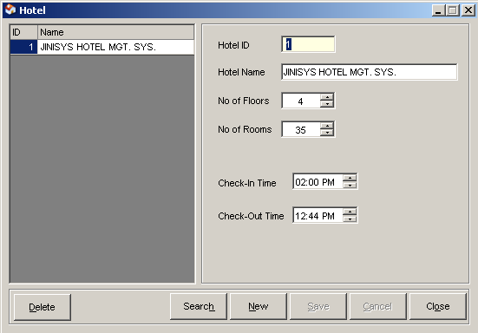
1

8

9

10
11
12
13
7

6

2

4

3

5

Figure II-1

- List of Hotels – enumerates the names of all managed hotels.
- Hotel ID field – displays the selected hotel’s ID.
- Hotel Name field – displays the selected hotel’s name.
- No. of Floors – displays the selected hotel’s number of floor levels.
- No of Rooms – displays the selected hotel’s number of rooms.
- Check-In Time – default check-in time of the selected hotel.
- Check-Out Time – default check-out time of the selected hotel.
- Delete button – removes the selected hotel from the list.
- Search button – searches for a specific hotel in the list.
- New button – prepares the window for a new hotel entry.
- Save button – saves the new or modified hotel information.
- Cancel button – discards modification of or creation of hotel information.
- Close button – closes the Hotel window.

? How to INSERT a New Hotel

  - From the Menu Bar, click Configuration then select Hotel and click Hotel Information. This will launch the Hotel window.
  - In the Hotel window, click the New button.
  - Enter the hotel information in the appropriate fields at the right side of the screen. Hotel ID must be unique.
  - Click on Save button to save the new hotel.
Click Ok when prompted that the entry was successfully added. The hotel you saved will be added to the hotel list.
  - Click on Cancel button to discontinue adding a new hotel.

? How to EDIT Information of an existing Hotel

- In the Hotel window, select the hotel you want to edit by clicking it once. Then modify the necessary details (except Hotel ID: unique identifier of the hotel) at the right side of the screen.
- Click on Save button to save the changes.
Click Ok when prompted that the entry was successfully updated. The hotel information will be updated in the list.
- Click on Cancel button to discard the changes.

? How to DELETE a Hotel

- In the Hotel window, select the hotel from the hotel list and click the Delete button.
- Click on YES button when prompted if you are sure you want to delete the
hotel. The hotel will be removed from the list.
- Click on NO button to cancel the deletion.
Do you know that…

Yellow-colored boxes are required fields. Required fields have to be filled out when you insert or edit a record. If the required field is blank, an alert box prompts you a message.

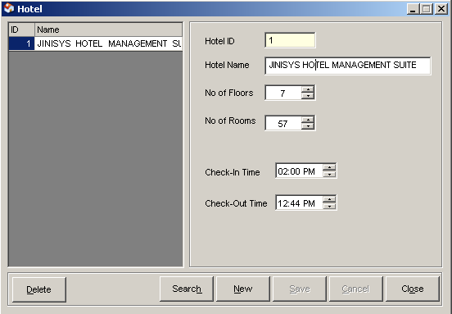

2. Department – contains the departments of the hotel.
Location: Configuration > Hotel > Departments

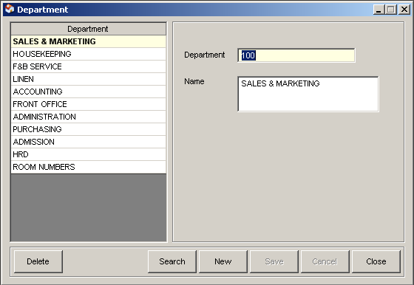
2

3

1

4

5

6

7

8

9

Figure II-2

- List of Departments – enumerates the department names of the hotel.
- Department field – holds the selected department’s code.
- Name field – displays the selected department’s name.
- Delete button – removes the selected department from the list.
- Search button – searches for a specific department in the list.
- New button – prepares the window for a new department entry.
- Save button – saves the new or modified department.
- Cancel button – discards modification of or creation of department information.
- Close button – closes the Department window.

? How to INSERT a New Department

- From the Menu Bar, click Configuration then select Hotel and click Department. This will launch the Department window.
- In the Department window, click the New button.
- Enter the department information in the appropriate fields at the right side of the screen. Department ID must be unique.
- Click on Save button to save the new department.
Click Ok when prompted that the entry was successfully added. The department you saved will be added to the departments list.
- Click on Cancel button to discontinue adding a new department.

? How to EDIT Information of an existing Department

- In the Department window, select department you want to edit in the list by clicking it once. Then modify the necessary details (except Department: unique identifier of the department) at the right side of the screen.
- Click on Save button to save the changes.
Click the Ok button when prompted that the entry was successfully updated. The department information will be updated in the list.
- Click on Cancel button to discard the changes.

? How to DELETE a Department

- In the Department window, select the department from the department list and click the Delete button.
- Click Yes when prompted if you are sure you want to delete the department. The department will be removed from the list.
- Click on No button to cancel the deletion.

3. Floor Plan – contains the layouts of all the hotel floor levels.
Location: Configuration > Hotel > Floor Plan
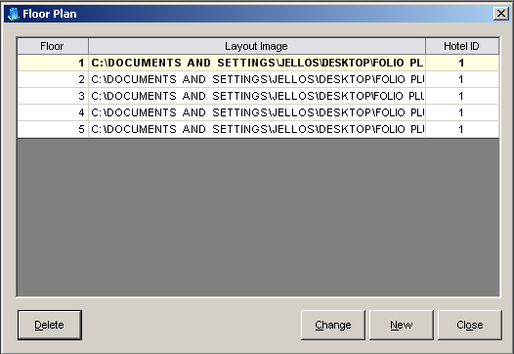
1
2
3
4
5

Figure II-3

- List of Floors – enumerates all floor levels of the hotel.
- Delete button – deletes the selected floor layout.
- Change button – replaces the selected level’s floor layout image.
- New button - prepares the window for a new floor level entry.
- Close button – closes the Floor Plan window.

? How to INSERT a New Floor Level

- From the Menu Bar, click Configuration then select Hotel and click Floor Plan. This will launch the Floor Plan window.
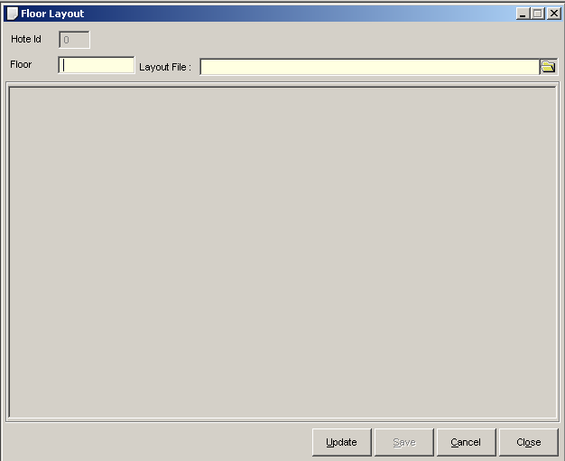
- In the Floor Plan window, click the New button. Floor Layout window will appear.

Figure II-4
- Enter the floor level on the Floor text field and browse the file of the floor layout by clicking the (browse) button beside the Layout File field.
- Click on Save button to save the new floor level.
Click Ok when prompted that the entry was successfully added. The floor will be added to the floor level list in the Floor Plan window (Figure II-3).
- Click on Cancel button to discontinue adding a new floor level.

? How to EDIT Information of an existing Floor Level

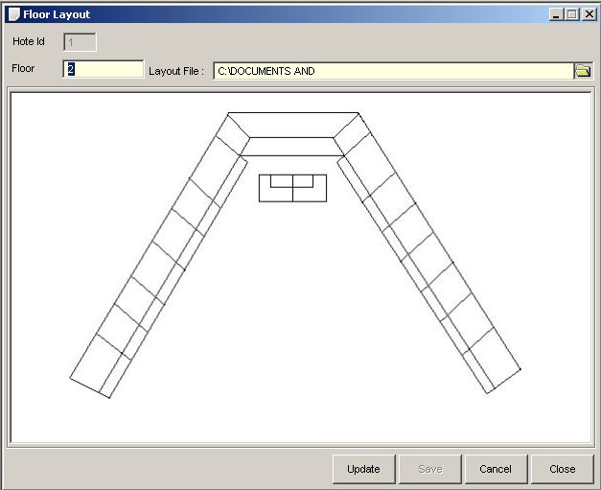
- In the Floor Plan window, select the floor level you want to edit by clicking it once, and click Change button. Floor Layout window will be displayed.

Figure II-5
- Browse the file of the floor layout image by clicking the (browse) button.
- Click on Update button to save the changes.
Click Ok when prompted signifying the entry was successfully updated. The floor will be updated in the list.
- Click on Cancel button to discard the changes.

? How to DELETE a Floor Level

- In the Floor Plan window, select the floor level from the floor level list and click the Delete button.
- Click on Yes button when prompted if you are sure you want to delete the floor. The floor level and its layout will be removed from the list.
- Click on No button to cancel the deletion.
4. Currency – records all currencies that the hotel accepts.
Location: Configuration > Currency Codes

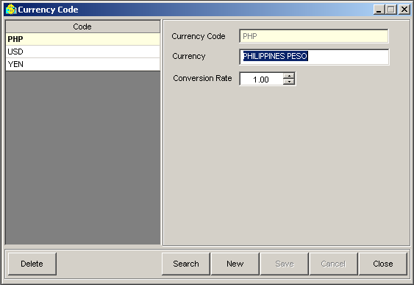
5

6

7

8

9

10

2

4

3

6

Figure II-6

- List of Currencies – enumerates all currency codes of the hotel.
- Currency Code field – holds the selected currency’s code.
- Currency field – displays the selected currency’s description.
- Conversion Rate – displays the selected currency’s exchange rate against the Philippine peso.
- Delete button – removes the selected currency from the list.
- Search button – searches for a specific currency in the list.
- New button – prepares the window for a new currency entry.
- Save button – saves the new or modified currency.
- Cancel button – discards the modification of or creation of currency information.
- Close button – closes the Currency Code window.

? How to INSERT a New Currency

  - From the Menu Bar, click Configuration and select Currency Codes. This will launch the Currency Code window.
  - In the Currency Code window, click the New button.
  - Enter the currency information in the appropriate fields at the right side of the screen. Currency Code must be unique.
Note: Base currency is PHP.
  - Click on Save button to save the new currency.
Click Ok when prompted that the entry was successfully added. The currency you saved will be added to the currency list.
  - Click on Cancel button to discontinue adding a new currency.

? How to EDIT Information of an existing Currency

- In the Currency Code window, select the currency you want to edit in the list by clicking it once. Then modify the necessary details (except Currency Code: unique identifier of the currency).
- Click on Save button to save the changes.
Click Ok when prompted that the entry was successfully updated. The currency will be updated in the list.
- Click on Cancel button to discard the changes.

? How to DELETE a Currency

- In the Currency Code window, select the currency from the currency list and click the Delete button.
- Click on Yes button when prompted if you are sure you want to delete the currency. The currency will be removed from the list.
- Click on No button to cancel the deletion.

5. Room Types – records all room types of the hotel.
Location: Configuration > Room > Room Types

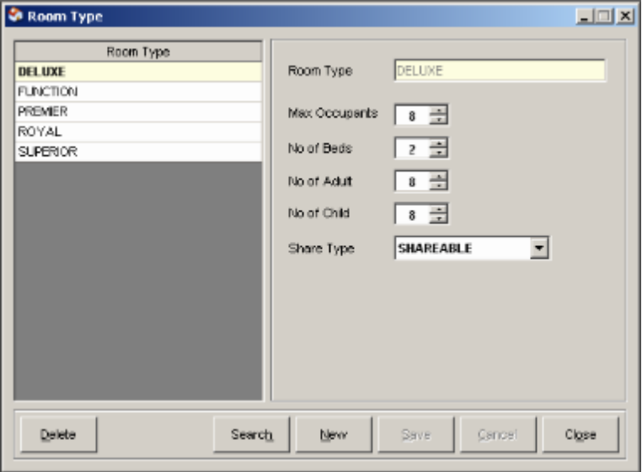
2
3
4
5
6
7
1
8
9
10
11
13
12

Figure II-7

- List of Room Types – enumerates all room types of the hotel.
- Room Type field – holds the selected room type’s name.
- Max. Occupants – displays the selected room type’s maximum number of occupants.
- No. of Beds – displays the selected room type’s the number of beds.
- No. of Adult – displays the total number of adults the selected room type can accommodate.
- No. of Child – displays the total number of children the selected room type can accommodate.
- Share Type field – displays if the selected room type can be shared with another guest or not.
- Delete button – removes the selected room type from the list.
- Search button – searches for a specific room type in the list.
- New button – prepares the window for a new room type entry.
- Save button – saves the new or modified room type.
- Cancel button – discards modification of or creation of room type information.
- Close button – closes the Room Type window.

? How to INSERT a New Room Type

  - From the Menu Bar, click Configuration then select Room and click Room Types. This will launch the Room Type window.
  - In the Room Types window, click the New button
  - Enter the room type information in the appropriate fields at the right side of the screen. Room Type must be unique.
4 Click on Save button to save the new room type.
Click the OK button when prompted that the entry was successfully added. The room type you saved will be added to the room types list.
5 Click on Cancel button to discontinue adding a new room type.

? How to EDIT Information of an existing Room Type

- In the Room Type window, select room type you want to edit in the list by clicking it once. Then modify the necessary details (except Room Type: unique identifier of a room type) at the right side of the screen.
- Click on Save button to save the changes.
Click the OK button when prompted that the entry was successfully updated. The room type will be updated in the list.
- Click on Cancel button to discard the changes.

? How to DELETE a Room Type

- In the Room Type window, select room type from the room type selection list and click the Delete button.
- Click on Yes button when prompted if you are sure you want to delete the room type. The room type will be removed from the list.
- Click on No button to cancel the deletion.

6. Room Amenities – records all amenities that the rooms of the hotel have.
Location: Configuration > Room > Room Amenities
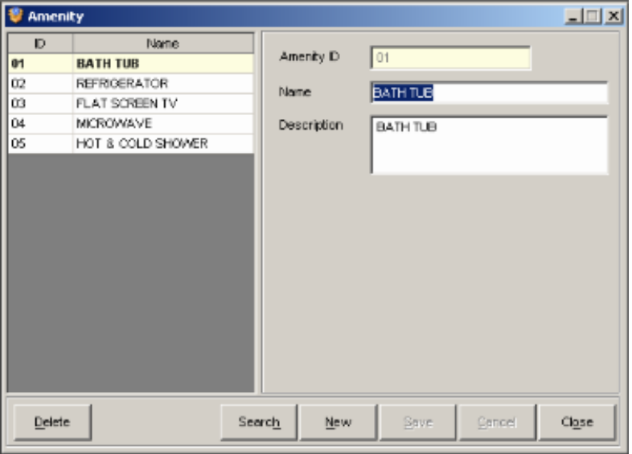
2
3
4
1
5
6
7
8
9
10

Figure II-8

- List of Amenities – enumerates all amenities that the hotel rooms may have.
- Amenity ID field – holds the selected amenity’s ID.
- Name field – displays the selected amenity’s name.
- Description field – displays the selected amenity’s description.
- Delete button – removes selected amenity from the list.
- Search button – searches for a specific amenity in the list.
- New button – prepares the window for a new amenity entry.
- Save button – saves the new or modified amenity.
- Cancel button – discards modification of or creation of amenity information.
- Close button – closes the Amenity window.

? How to INSERT a New Amenity

- From the Menu Bar, click Configuration then select Room and click Room Amenities. This will launch the Amenity window.
- In the Amenity window, click the New button.
- Enter the amenity information in the appropriate fields at the right side of the screen. Amenity ID must be unique.
- Click on Save button to save the new amenity.
Click OK when prompted that the entry was successfully added. The amenity you saved will be added to the Amenity list.
- Click on Cancel button to discontinue adding a new amenity.

? How to EDIT Information of an existing Amenity

- In the Amenity window, select the amenity you want to edit in the list by clicking it once. Then modify the necessary details (except Amenity ID: unique identifier of an amenity) at the right side of the screen.
- Click on Save button to save the changes.
Click Ok when prompted that the entry was successfully updated. The amenity will be updated in the list.
- Click on Cancel button to discard the changes.

? How to DELETE an Amenity

- In the Amenity window, select amenity from the amenity list and click the Delete button.
- Click on Yes button when prompted if you are sure you want to delete the amenity. The amenity will be removed from the list.
3. Click on No button to cancel the deletion.

7. Rooms – records all rooms in the hotel.
Location: Configuration > Room > Rooms
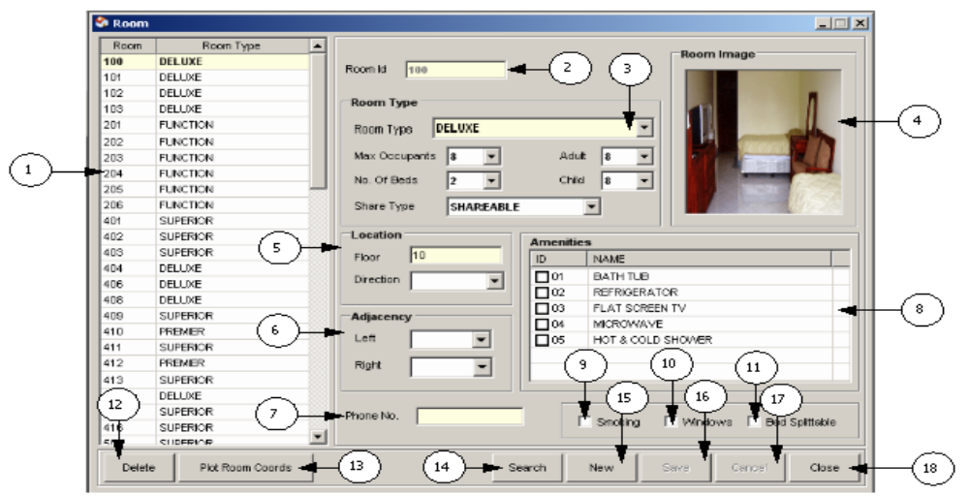

Figure II-9

- List of Rooms – enumerates all rooms of the hotel.
- Room ID field – holds the selected room’s ID or number.
- Room Type field – displays the selected room’s type.
- Room Image – displays the selected room’s image.
- Location fields – displays the selected room’s location.
- Adjacency fields – displays the rooms adjacent to the selected room.
- Phone No. field – displays the selected room’s local number.
- Amenities list – enumerates all amenities available (checked) in the selected room.
- Smoking check-box – shows if smoking is allowed in the selected room.
- Windows check-box – shows if the selected room has windows.
- Bed check-box – shows if the selected room’s bed can be split up.
- Delete button – removes the selected room from the list.
- Plot room coordinates – shows the floors layout image where the selected room’s coordinates can be plot.
- Search button – searches for a specific room in the list.
- New button – prepares the window for a new room entry.
- Save button – saves the new or modified room.
- Cancel button – discards modification of or creation of room information.
- Close button – closes the Room window.

? How to INSERT a New Room

  - From the Menu Bar, click Configuration then select Room and click Rooms. This will launch the Room window.
  - In the Room window, click the New button.
  - Enter the room information in the appropriate fields at the right side of the screen. Room ID must be unique.
  - Click on Save button to save the new room.
Click Ok when prompted that the entry was successfully added. The room you saved will be added to the Room list.
  - Click on Cancel button to discontinue adding a new room.

? How to EDIT Information of an existing Room

- In the Room window, select the room you want to edit in the list by clicking it once. Then modify the necessary details (except Room Id: unique identifier of the room) at the right side of the screen.
- Click on Save button to save the changes.
Click Ok when prompted that the entry was successfully updated. The room will be updated in the list.
- Click on Cancel button to discard the changes.

? How to DELETE a Room

- In the Room window, select the room from the room list and click the Delete button.
- Click on Yes button when prompted if you are sure you want to delete the room. The room will be removed from the list.
- Click on No button to cancel the deletion.

? How to PLOT a Room’s coordinate

- In the Room window, click the Plot Room Coords button. This will launch the Floor Layout window.
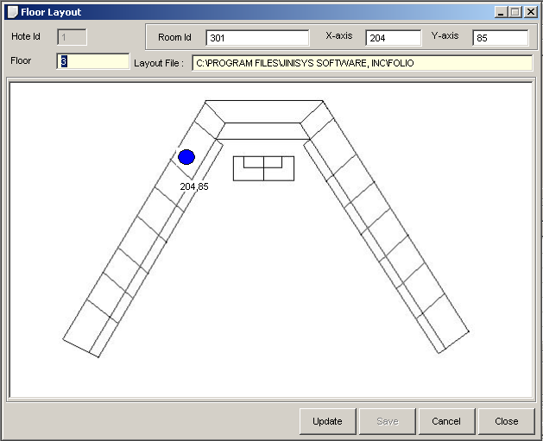

Do you know that…

● You can view a larger image of a room by pointing the mouse over the room image box in the Room window.
● The room’s Telephone No. is the basis for Guest auto-charging.

Figure II-10
- Click on the image of the room’s location (blue-colored dot). Then Click Update button. System will return to Room window.
- Click on Save button to update room coordinates.

8. Rate Codes – records all rate codes of a hotel.
Location: Configuration > Room Rates > Rate Codes
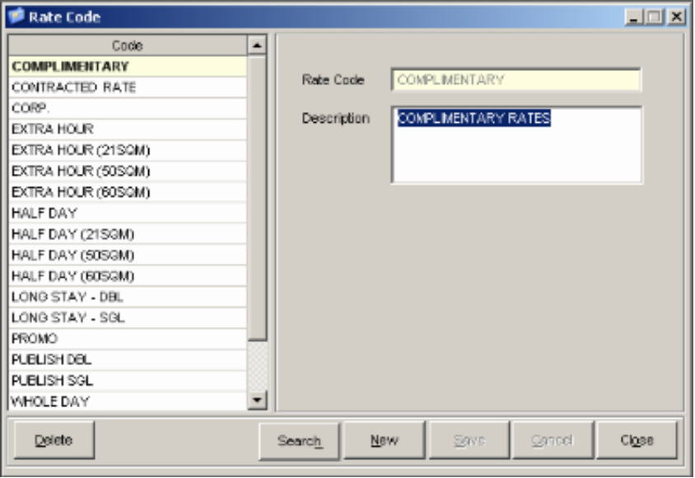
1
4
5
6
7
8
9
3
2

Figure II-11

- List of Rate Codes – enumerates all active rate codes.
- Rate Code field – holds the rate code.
- Description field – displays rate code description.
- Delete button – removes selected rate code from the list.
- Search button – search for a specific rate code in the list.
- New button – prepares the screen for a new rate code entry.
- Save button – saves the new or modified rate code.
- Cancel button – discards modification of or creation of rate code information.
- Close button – closes the Rate Code window.

? How to INSERT a New Rate Code

- From the Menu Bar, click Configuration then select Room Rates and click Rate Codes. This will launch the Rate Code window.
- In the Rate Code window, click the New button.
- Enter the rate code and description in the appropriate fields at the right side of the screen. Rate Code must be unique.
- Click on Save button to save the new rate code.
Click Ok when prompted that the entry was successfully added. The rate code you saved will be added to the rate code list.
- Click on Cancel button to discontinue adding a new rate code.
? How to EDIT Information of an existing Rate Code

- In the Rate Code window, select the rate code you want to edit from the list by clicking it once. Then modify the necessary details (except Rate Code: unique identifier of the rate code) at the right side of the screen.
- Click on Save button to save the changes.
Click Ok when prompted that the entry was successfully updated. The rate code will be updated in the list.
- Click on Cancel button to discard the changes.

? How to DELETE a Rate Code

- In the Rate Code window, select the rate code from the rate code list and click the Delete button.
- Click on Yes button when prompted if you are sure you want to delete
the rate code. The rate code will be removed from the list.
3. Click on No button to cancel the deletion.

9. Rate Types – records all rate types that the rooms of a hotel have.
Location: Configuration > Room Rates > Rate Types
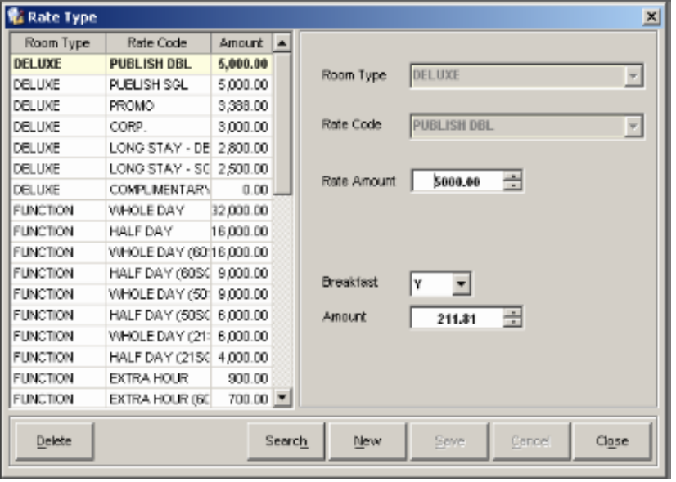
2
3
4
5
6
7
1
8
9
10
11
12

Figure II-12

- List of Rate Types – enumerates all active rate types of a hotel.
- Room Type field – holds the selected room’s type.
- Rate Code field – displays the selected rate type’s code.
- Rate Amount – displays the selected rate type’s amount.
- Breakfast field – shows if the selected rate type includes Breakfast.
- Amount field – displays the selected rate type’s breakfast amount.
- Delete button – removes the selected rate type from the list.
- Search button – searches for a specific rate type in the list.
- New button – prepares the screen for a new rate type entry.
- Save button – saves the new or modified rate type.
- Cancel button – discards modification of or creation of rate type information.
- Close button – closes the Rate Type window.

? How to INSERT a New Rate Type

- From the Menu Bar, click Configuration then select Room Rates and click Rate Types. This will launch the Rate Type window.
- In the Rate Type window, click the New button.
- Enter Rate Type information in the appropriate fields at the right side of the screen.
- Click on Save button to save the new rate type.
Click the OK button when prompted that the entry was successfully added. The rate type you saved will be added to the Rate Type list.
- Click on Cancel button to discontinue adding a new rate type.

? How to EDIT Information of an existing Rate Type

- In the Rate Type window, select the rate type you want to edit from the list by clicking it once. Then modify necessary details (except Room Type and Rate Code: unique identifier of the rate type) at the right side of the screen.
- Click on Save button to save the changes.
Click the OK button when prompted that the entry was successfully updated. The rate type will be updated in the list.
- Click on Cancel button to discard the changes.

? How to DELETE a Rate Type

- In the Rate Type window, select the rate type from the rate type list and click the Delete button.
- Click on Yes button when prompted if you are sure you want to delete the rate type. The rate type will be removed from the list.
3. Click on No button to cancel the deletion.

10. Transaction Types – records all transaction types of a hotel. Transaction Types are groups of Transaction codes.
Location: Configuration > Transaction > Transaction Types

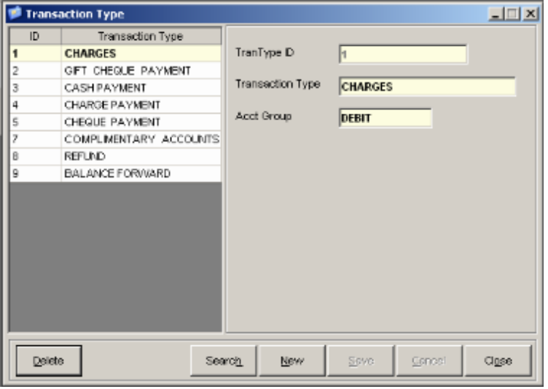
2
3
4
1
7
8
9
10
5
6

Figure II-13

- List of Transaction Types– enumerates all transaction types of the hotel.
- TranType ID – displays the selected trans. type’s ID.
- Transaction Type field – displays the selected trans. type’s description.
- Acct. Group field – displays the accounting side to where the selected trans. type falls under.
- Delete button – removes selected transaction type from the list.
- Search button – searches for a specific transaction type in the list.
- New button – prepares the screen for a new transaction type entry.
- Save button – saves the new or modified transaction type.
- Cancel button – discards modification of or creation of transaction type information.
- Close button – closes the Transaction Type window.

? How to INSERT a New Transaction Type

- From the Menu Bar, click Configuration then select Transaction and click Transaction Types. This will launch the Transaction Type window.
- In the Transaction Type window, click the New button.
- Enter the transaction type details in the appropriate fields at the right side of the screen. Transaction Type ID must be unique.
- Click on Save button to save the new transaction type.
Click Ok when prompted that the entry was successfully added. The transaction type will be added to the Transaction Type list.
- Click on Cancel button to discontinue adding a new transaction type.

? How to EDIT Information of an existing Transaction Type

- In the Transaction Type window, select the transaction type you want to edit in the list by clicking it once. Then modify the necessary details (except TranType ID: unique identifier of the transaction type).
- Click on Save button to save the changes.
Click Ok when prompted that the entry was successfully updated. The transaction type will be updated in the list.
- Click on Cancel button to discard the changes.

? How to DELETE a Transaction Type

- In the Transaction Type window, select transaction type in the transaction type selection list and click the Delete button.
- Click on Yes button when prompted if you are sure you want to delete the transaction type. The transaction type will be removed from the list.
- Click on No button to cancel the deletion.

11. Transaction Source Documents – records all transaction source documents of the hotel.
Location: Configuration > Transaction > Transaction Sources
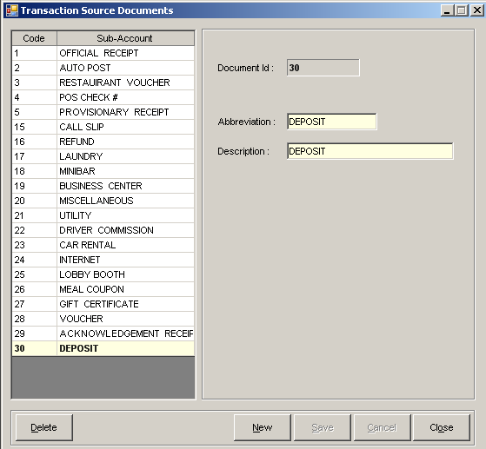
2
3
1
5
6
7
4
8
9

Figure II- 14

- List of Trans. Source Documents (TSDs)
– enumerates all TSDs of the hotel.
- Document Id field – displays the selected TSD’s ID.
- Abbreviation field – displays the selected TSD’s abbreviation.
- Description field – displays the selected TSD’s description.
- Delete button – removes the selected TSD from the list.
- New button – prepares the window for a new TSD entry.
- Save button – saves the new or modified TSD.
- Cancel button – discards modification of or creation of TSD information.
- Close button – closes the Trans. Source Documents window.

? How to INSERT New Transaction Source Document

- From the Menu Bar, click Configuration then select Transaction and click Transaction Sources. This will launch the Transaction Source Documents (TSDs) window.
- In the TSDs window, click the New button. Document ID is automatically set by the system.
- Enter the abbreviation and description in the appropriate fields at the right side of the screen.
- Click on Save button to save the new TSD.
Click Yes when prompted if you are sure to save new TSD entry. The TSD will be added to the TSDs list.
- Click on Cancel button to discontinue adding a new TSD.

? How to EDIT Information of an existing Transaction Source Document

  - In the Transaction Source Documents (TSDs) window, select the transaction source you want to edit in the list by clicking it once.
  - Then modify the necessary details (except Document Id: unique identifier of the transaction source document) at the right side of the screen.
  - Click on Save button to save the changes.
Click Yes when prompted if you are sure to save the new TSD entry. The TSD will be updated in the list.
  - Click on Cancel button to discard the changes.

? How to DELETE a Transaction Source Document

- In the Transaction Source Documents (TSDs) window, select the TSD from the TSDs list and click the Delete button.
- Click Yes when prompted if you are sure you want to delete the TSD. The TSD will be removed from the list.
- Click on No button to cancel the deletion.

12. Transaction Codes – records all transaction codes of a hotel.
Location: Configuration > Transaction > Transaction Codes

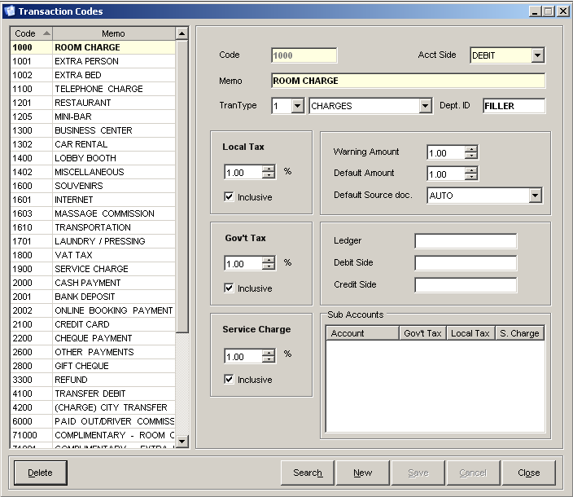
5
6
4
2
3
9
10
11
14
15
16
19
21
22
23
24
25
1
7
8
12
131
17
18
20

Figure II-15

- List of Trans. Codes (TCs) – enumerates all active TCs of the hotel.
- Code field – holds the selected transaction’s code.
- Memo field – displays the selected TC’s description.
- Trans. type field – displays the selected TC’s type (Charge/Payment).
- Acct Side field – displays the Acctg. side (Debit/Credit) where the selected TC falls under.
- Department ID field – displays the Department ID where the TC falls under. This is used for Service Charge distribution.
- Local Tax – displays the selected TC’s local tax percentage.
- Local Tax Inclusive box – shows if local tax is included in the selected TC or not.
- Warning Amount – displays the selected TC’s warning amount.
- Default Amount – displays the selected TC’s default amount.
- Default Source Doc. field – displays the selected TC’s default Source Document.
- Govt. Tax (VAT) - displays the selected TC’s value added tax (VAT) percentage.
- Govt. Tax Inclusive box – shows if VAT is included in the selected TC or not.
- Ledger field – displays the selected TC’s Ledger destination if it is posted to an Accounting Ledger.
- Debit Side field – displays the selected TC’s debit Account Code mapped to Accounting System.
- Credit Side field – displays the selected TC’s credit Account Code mapped to Accounting System.
- Service Charge – displays the selected TC’s service charge percentage.
- Service Charge box – displays if service charge is included in the selected TC or not.
- Sub-Accounts List – enumerates the selected TC’s sub-accounts.
- Delete button – removes the selected TC from the list.
- Search button – searches for a specific TC in the list.
- New button – prepares the window for a new TC entry.
- Save button – saves the new or modified TC.
- Cancel button – discards modification of or creation of new TC information.
- Close button – closes the Transaction Codes window.

? How to INSERT a New Transaction Code

- From the Menu Bar, click Configuration then select Transaction and click Transaction Codes. This will launch the Transaction Code window.
- In the Transaction Codes (TCs) window, click the New button.
- Enter the TC details in the appropriate fields at the right side of the screen. Transaction Code must be unique.
- Click on Save button to save the new transaction code.
Click Ok when prompted that the entry was successfully added. The transaction code will be added to the TCs list.
- Click on Cancel button to discontinue adding a new TC.

? How to EDIT Information of an existing Transaction Code

- In the Transaction Codes window, select transaction code you want to edit in the list by clicking it once. Then modify the necessary details (except Transaction Code: unique identifier of the transaction code) at the right side of the screen.
- Click on Save button to save the changes.
Click Ok when prompted signifying that the entry was successfully updated. The transaction code will be updated in the list.
- Click on Cancel button to discard the changes.

? How to DELETE a Transaction Code

- In the Transaction Codes window, select the TC from the transaction code selection list and click the Delete button.
- Click on Yes button when prompted if you are sure you want to delete the transaction code. The transaction code will be removed from the list.
- Click on No button to cancel the deletion.

13. Transaction Code Sub-Accounts – records all transaction code sub-accounts of a hotel.
Location: Configuration > Transaction > Transaction Code Sub-Accounts
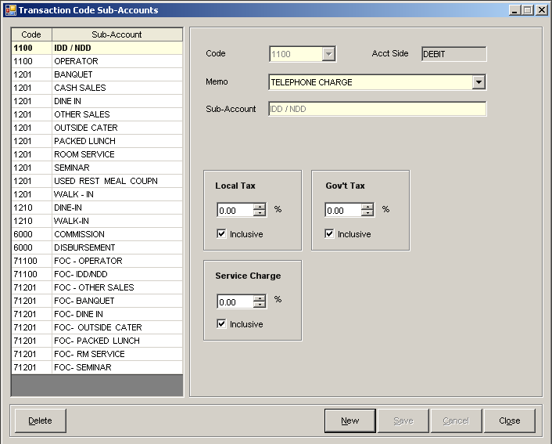
11
1
6
10
2
3
5
4
8
9
12
13
14
16
15
7

Figure II-15

- List of Trans. Code Sub-Accounts (TCS)
– enumerates all active Sub-Accounts that the Transaction Codes of a hotel have.
- Code field – holds the selected TCS’ code.
- Memo field – displays the selected TCS’ description.
- Account Side field - displays the Acctg. side (Debit/Credit) where the selected TCS falls under.
- Sub-Account field – displays the selected TCS’ description.
- Local Tax – displays the selected TCS’ local tax percentage.
- Local Tax Inclusive box – shows if local tax is included in the selected TCS or not.
- Govt. Tax (VAT) - displays the selected TCS’ value added tax (VAT) percentage.
- Govt. Tax Inclusive box – shows if VAT is included in the selected TCS or not.
- Service Charge – displays the selected TCS’ service charge percentage.
- Service Charge box – displays if service charge is included in the selected TCS or not.
- Delete button – removes the selected TCS from the list.
- Search button – search for a specific TCS in the list.
- New button – prepares the window for a new TCS entry.
- Save button – saves the new or modified TCS.
- Cancel button – discards modification of or creation of TCS information.
- Close button – closes Transaction Code Sub-Account window.

? How to INSERT a New Transaction Code Sub-Account

- From the Menu Bar, click Configuration then select Transaction and click Transaction Code Sub-Accounts. This will launch the Transaction Code Sub-Accounts window.
- In the Transaction Code Sub-Accounts (TSC) window, click the New button.
- Enter TCS details in the appropriate fields at the right side of the screen. Trans. Code Sub-Account must be unique.
- Click on Save button to save the new TCS.
Click Ok when prompted that the entry was successfully added. The TCS will be added to the TCS list.
- Click on Cancel button to discontinue adding a new TCS.

? How to EDIT Information of an existing Transaction Code Sub-Account

- In the Transaction Code Sub-Accounts (TCS) window, select the TCS you want to edit in the list by clicking it once. Then modify the necessary details (except Trans. Code Sub-Account: unique identifier of the sub-account) at the right side of the screen.
- Click on Save button to save the changes.
Click Ok when prompted that the entry was successfully updated. The TCS-account will be updated in the list.
- Click on Cancel button to discard the changes.

? How to DELETE a Transaction Code Sub-Account

- In the Transaction Code Sub-Accounts (TCS) window, select sub-account in the sub-account selection list and click the Delete button.
- Click on Yes button when prompted if you are sure you want to delete the TCS. The sub-account will be removed from the list.
- Click on No button to cancel the deletion.

14. Event Requirements – records all event requirements of a hotel. Event requirements are used in setting up Event Packages.
Location: Configuration > Events > Requirements
4
5
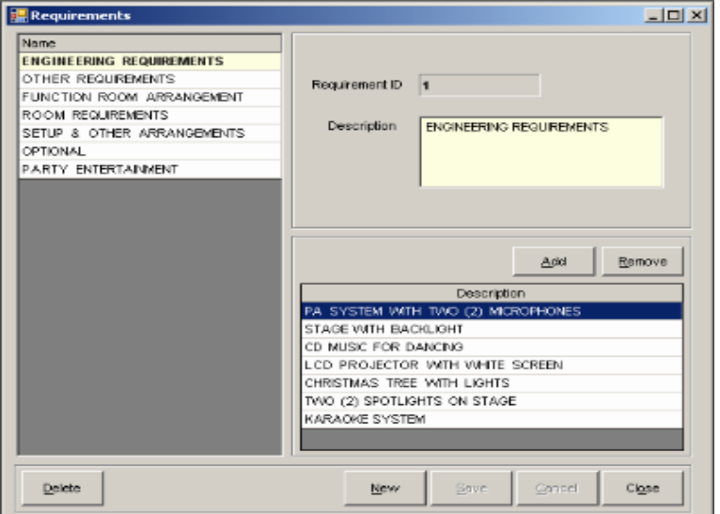
1
6

2
4
5
3
7
8
11
9
10

Figure II-16

- List of Requirements – enumerates all requirements that the events of a hotel have.
- Requirement ID field – holds the selected requirement’s ID.
- Description field – displays the selected requirement’s description.
- Add button – adds a new event requirement.
- Remove button – removes the selected requirement detail from the requirement.
- Requirement Details List – enumerates the selected requirement’s details.
- Delete button – removes the selected requirement from the list.
- New button – prepares the window for a new requirement entry.
- Save button – saves the new or modified requirement.
- Cancel button – discards modification of or creation of requirement information.
- Close button – closes the Requirements window.

? How to INSERT a New Event Requirement

  - From the Menu Bar, click Configuration then select Events and click Requirements. This will launch the Requirements window.
  - In the Requirements window, click the New button. Requirement ID is automatically set by the system.
  - Input the event requirement description in the appropriate fields at the right side of the screen.

? How to Add Requirement Detail
      - Click the Add button.
      - Enter requirement detail description on the appropriate field.
Requirement Detail will be added to the list.

? How to Edit Requirement Detail
1. Select the requirement detail from the requirement details list, and click on it to make changes.
Requirement Detail will be updated in the list.

? How to Remove Requirement Detail
            - Select the requirement detail by clicking it in the selection list, and click the Remove button.
Requirement Detail will be removed from the list.

- Click on Save button to save the new event requirement.
To proceed, click Yes when prompted to save new event requirement. The requirement will be added to the Requirements list.
- Click on Cancel button to discontinue adding a new event requirement.

? How to EDIT Information of an existing Event Requirement

- In the Requirements window, select the requirement you want to edit in the list by clicking it once. Then modify the necessary details (except Requirement ID: unique identifier of the event requirement) at the right side of the screen.
- Click on Save button to save the changes.
Click Yes when prompted to save requirement changes. The event requirement will be updated in the list.
- Click on Cancel button to discard the changes.

? How to DELETE an Event Requirement

- In the Requirements window, select requirement from the event requirement selection list and click the Delete button.
- Click on Yes button when prompted if you are sure you want to delete the requirement. The event requirement will be removed from the list.
- Click on No button to cancel the deletion.

15. Event Types – records all event types. Event Types are used in setting-up Event
Packages.
Location: Configuration > Events > Event Types

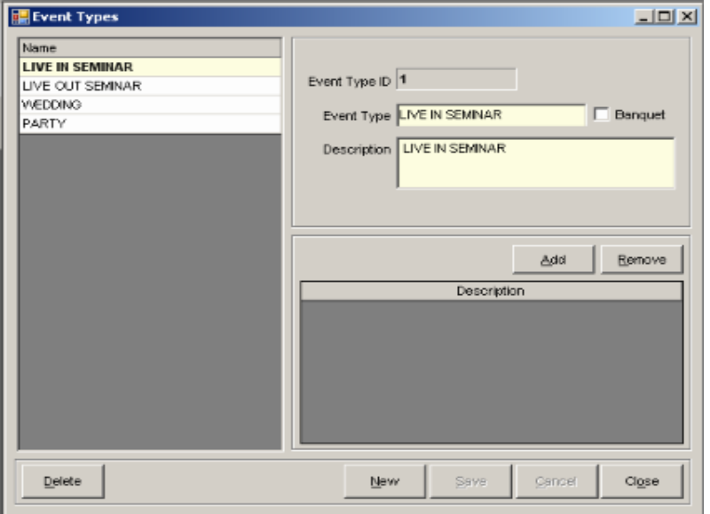
1
9
10
11
12
13
6
7
8
3
2
4
5

Figure II-17

- List of Event Types – enumerates all event types that the hotel has.
- Event Type Id field – holds the selected event type’s id.
- Event Type field – displays the selected event type’s name.
- Banquet box – shows if the selected event type is a banquet.
- Description field – displays the selected event type’s description.
- Add button – adds a new event detail to the selected event type.
- Remove button – removes the selected event detail from the selected event type.
- List of Event Details – enumerates all event details that the selected event type has.
- Delete button – removes the selected event type from the list.
- New button – prepares the window for a new event type entry.
- Save button – saves the new or modified event type.
- Cancel button – discards modification of or creation of event type information.
- Close button – closes the Event Types window.

? How to INSERT a New Event Type

  - From the Menu Bar, click Configuration then select Events and click Event Types. This will launch the Event Types window.
  - In the Event Types window, click the New button. This will create new event type. Event Type ID is automatically set by the system.
  - Enter event type and description. Check Banquet check box if necessary for the event type.

? How to Add an Event Detail to an Event Type
            - Click the Add button, and enter the event detail.
Event detail will be added to the list.

? How to Remove an Event Detail from an Event Type
1. Select event detail from the list of event details, and click the Remove button.
Event detail will be removed from the list.

? How to EDIT Information of an Event Detail
              - Click on the event detail in the event details list, and then modify the necessary details.
Event detail will be updated in the list.

4. Click on Save button to save the new event type.
Click the YES button when prompted to save new event type. The event type will be added to the event types list.
5. Click on Cancel button to discontinue adding a new event type.

? How to EDIT Information of an existing Event Type

- In the Event Types window, select the event type you want to edit by clicking it once. Then modify the necessary details (except Event Type ID: unique identifier of the event type) at the right side of the screen.
- Click on Save button to save the changes.
Click Yes when prompted to save the event type changes. The event type will be updated in the list.
- Click on Cancel button to discard the changes.

? How to DELETE an Event Type

- In the Event Types window, select event type from the event types list and click the Delete button.
- Click on Yes button when prompted if you are sure you want to delete the event type. The event type will be removed from the list.
- Click on No button to cancel the deletion.

16. Event Package – records all Event Packages of the hotel.
Location: Configuration > Events > Package
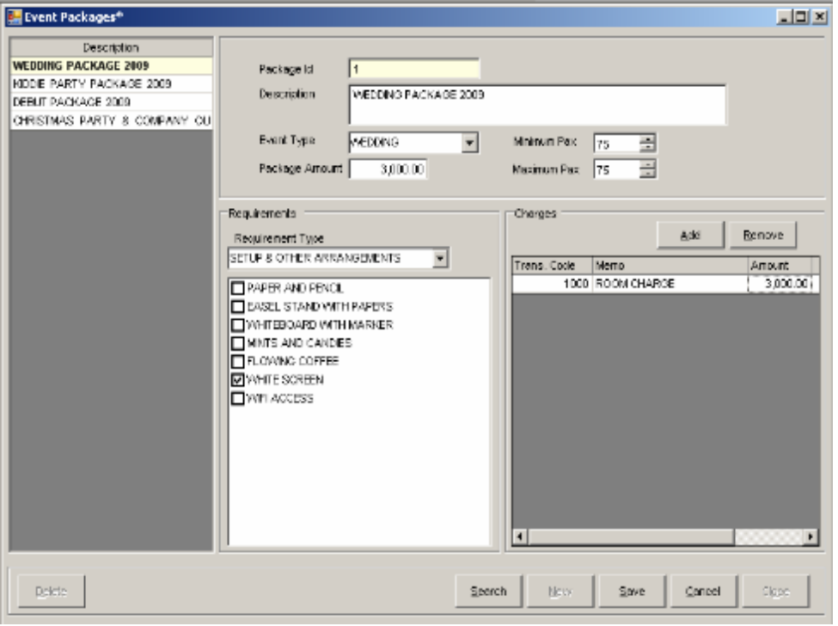
4
5
2
1
9
8
7
6
3
10
11
12
18
14
15
16
17
13

Figure II-18

- List of Packages – enumerates all active event packages of the hotel.
- Package ID field – holds the selected package’s ID.
- Description field – displays the selected package’s description.
- Event Type field – displays the selected package’s event type.
- Package Amount field – displays the selected package’s price.
- Minimum Pax – displays the selected package’s minimum number of persons to accommodate.
- Maximum Pax – displays the selected package’s maximum number of persons to accommodate.
- Event Requirement field – displays the event requirement type/s included in the package.
- Event Requirement details list
– displays the requirement details that are included (checked) in the package.
- Add button – adds a new item that will be included in the selected package.
- Remove button – removes the selected item from the selected package.
- List of Package Inclusions – enumerates all items included in the selected package with their prices.
- Delete button – removes the selected Event Package from the list.
- Search button – searches for a specific Event Package in the list.
- New button – prepares the window for a new event package entry.
- Save button – saves the new or modified event package.
- Cancel button – discards modification of or creation of event package information.
- Close button – closes the Event Package window.

? How to INSERT a New Event Package

                - From the Menu Bar, click Configuration then select Events and click Package. This will launch the Event Packages window.
                - In the Event Packages window, click the New button. Event Package Id is automatically set by the system.
                - Enter event package details in the appropriate fields at the right side of the screen.

? How to Add Requirements
- Select requirement type from the Requirement Type drop down list.
- Click on the corresponding boxes of the requirements you want to include.
Requirements will be added to the list.

? How to Remove Requirements
- Select requirement type from the Requirement Type drop down list.
- Uncheck the requirements you want to remove by clicking on their checked boxes.
Requirements will be removed from the list.

? How to Add Charges
- Click the Add button. An empty cell will appear. Choose the transaction code from the list.
- Change the transaction description if necessary and enter the amount of charge.
Charge will be added in the list.

? How to Remove Charges
- Select the charge by clicking it in the charge selection list, and click the Remove button.
Charge will be removed from the list.

4. Click on Save button to save the new event package.
Click Ok when prompted signifying the entry was successfully added. The event package will be added to the Event Packages list.
5. Click on Cancel button to discontinue adding a new event package.

? How to EDIT Information of an existing Package

1. In the Event Packages window, select the event package you want to edit by clicking it once. Then modify the necessary details (except Package ID: unique identifier of the package) at the right side of the screen.

2. Click on Save button to save the changes.
Click Ok when prompted signifying that the entry was successfully updated. The event package will be updated in the list.
3. Click on Cancel button to discard the changes.

? How to DELETE a Package

- In the Event Packages window, select package from the event package selection list and click the Delete button.
- Click on Yes button when prompted if you are sure you want to delete the package. The event package will be removed from the list.
- Click on No button to cancel the deletion.

17. Event Applied Rates – records all Applied Rates for events. Applied Rates are used in Group Check-In with Room Accommodation.
Location: Configuration > Events > Applied Rates
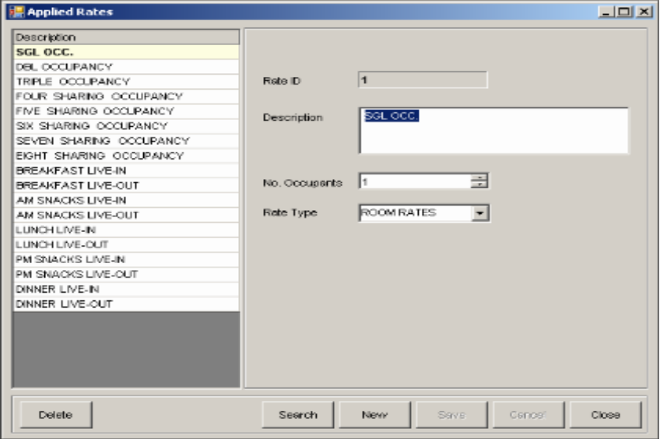
4
5
3
2
7
8
9
10
11
6
1

Figure II-19

- List of Applied Rates – enumerates all applied rates that the events of the hotel have.
- Rate Id field – holds the selected applied rate’s ID.
- Description field – displays the selected applied rate’s description.
- No. Of Occupants – displays the no. of occupants the selected applied rate can accommodate.
- Rate Type field – displays the rate type of selected applied rate.
- Delete button – removes the selected applied rate from the list.
- Search button – searches for a specific applied rate in the list.
- New button – prepares the window for a new applied rate entry.
- Save button – saves the new or modified applied rate.
- Cancel button – discards modification of or creation of new applied rate information.
- Close button – closes the Applied Rates window.

? How to INSERT a New Applied Rate

  - From the Menu Bar, click Configuration then select Events and click Applied Rates. This will launch the Applied Rates window.
  - In the Applied Rates window, click the New button. This will create a new applied rate. Rate ID is automatically set by the system.
  - Enter the necessary details at the right side of the screen.
4. Click on Save button to save the new applied rate.
Click Yes when prompted to save new applied rate. The applied rate will be added to the Applied Rates list.
5. Click on Cancel button to discontinue adding a new applied rate.

? How to EDIT Information of an existing Applied Rate

1. In the Applied Rates window, select the applied rate you want to edit by clicking it once. Then modify the necessary details (except Rate ID: unique identifier of the applied rate) at the right side of the screen.
2. Click on Save button to save the changes.
Click Yes when prompted to save applied rate changes. The applied rate will be updated in the list.
3. Click on Cancel button to discard the changes.

? How to DELETE an Applied Rate

- In the Applied Rates window, select applied rate in the rate selection list and click the Delete button.
- Click on YES button when prompted if you are sure you want to delete the rate. The applied rate will be removed from the list.
- Click on NO button to cancel the deletion.

18. Meal Groups – records all Meal Groups of the hotel.
Location: Configuration > Events > Meals > Meal Group
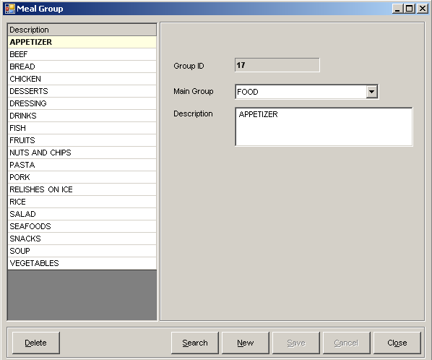
2
3
4
1
5
6
7
8
9
10

Figure II-20

- List of Meal Groups – enumerates all meal groups that the hotel has.
- Group ID field – holds the selected meal group’s id.
- Main Group field – displays the selected meal group’s main group (Food/ Beverage).
- Description field – displays the selected meal group’s description.
- Delete button – removes the selected meal group from the list.
- Search button – searches for a specific meal group in the list.
- New button – prepares the window for a new meal group entry.
- Save button – saves the new or modified meal group.
- Cancel button – discards modification of or creation of meal group information.
- Close button – closes the Meal Group window.

? How to INSERT a New Meal Group

  - From the Menu Bar, click Configuration then select Events, and select Meals then click Meal Group. This will launch the Meal Group window.
  - In the Meal Group window, click the New button. Group ID is automatically set by the system.
  - Select the main group and enter description in the appropriate fields at the right side of the screen.
            - Click on Save button to save the new meal group.
Click Yes when prompted to save new meal group entry. The meal group you saved will be added to the meal groups list.
            - Click on Cancel button to discontinue adding a new meal group.

? How to EDIT Information of an existing Meal Group

  - In the Meal Group window, select the meal group you want to edit in the list by clicking it once. Then modify the necessary details (except Group ID: unique identifier of the meal group).
  - Click on Save button to save the changes.
Click Yes when prompted to save meal group changes. The meal group will be updated in the list.
  - Click on Cancel button to discard the changes.

? How to DELETE a Meal Group

- In the Meal Group window, select meal group from the selection list and click the Delete button.
- Click on Yes button when prompted if you are sure you want to delete the meal group. The meal group will be removed from the list.
- Click on No button to cancel the deletion.

19. Meal Items – records all Meal Items of the hotel.
Location: Configuration > Events > Meals > Meal Item
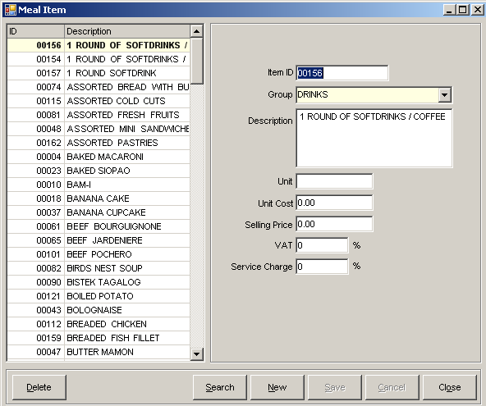
2
3
4
8
9
5
6
7
1
10
11
12
14
15
13

Figure II-21

- List of Meal Items – enumerates all meal items that the hotel has.
- Item ID field – holds the selected meal item’s ID.
- Group Id field – displays the selected meal item’s group.
- Description field – displays the selected meal item’s description.
- Unit field – displays the selected meal item’s unit.
- Unit Cost field – displays the selected meal item’s unit cost.
- Selling price field – displays the selected meal item’s selling price.
- VAT field – displays the selected meal item’s VAT percentage.
- Service Charge – displays the selected meal item’s service charge percentage.
- Delete button – removes the selected meal item from the list.
- Search button – searches for a specific meal item in the list.
- New button – prepares the window for a new meal item entry.
- Save button – saves meal item information changes or new meal
item entry.
- Cancel button – discards meal item information changes or new
entry.
- Close button – closes the Meal Item screen.

? How to INSERT a New Meal Item

    - From the Menu Bar, click Configuration then select Events, and select Meals then click Meal Item. This will launch the Meal Item window.
    - In the Meal Item window, click the New button.
    - Enter item id and description in the appropriate fields at the right side of the screen. Item ID must be unique.
    - Click on Save button to save the new Meal Item.
Click Yes when prompted to save new meal item entry. The meal item will be added to the Meal Items list.
    - Click on Cancel button to discontinue adding a new meal item.

? How to EDIT Information of an existing Meal Item

- In the Meal Item window, select the meal item you want to edit in the list by clicking it once. Then modify the necessary details (except Item ID: unique identifier of the meal item) at the right side of the screen.
- Click on Save button to save the changes.
Click Yes when prompted to save meal item changes. The meal item will be updated in the list.
- Click on Cancel button to discard the changes.

? How to DELETE a Meal Item

- In the Meal Item window, select meal item from the selection list and click the Delete button.
- Click Yes when prompted if you are sure you want to delete the item. The meal item will be removed from the list.
- Click on No to cancel the deletion.

20. Meal Menu – records all Meal Menus of the hotel. Meal Menus are collections of Meal Items used in combo meals.
Location: Configuration > Events > Meals > Meal Menus

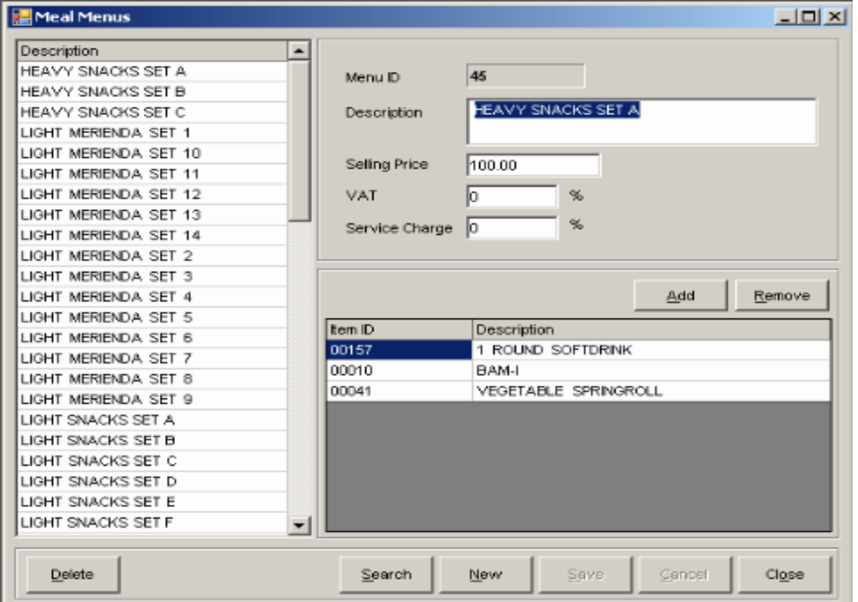
2
3
4
5
6
7
8
9
1
10
11
12
13
14
15

Figure II-22

- List of Meal Menus – enumerates all meal menus that the hotel has.
- Menu ID field – displays the selected meal menu’s ID.
- Description field – displays the selected meal menu’s description.
- Selling Price field – displays the selected meal menu’s selling price.
- VAT field – displays the selected meal menu’s VAT percentage.
- Service Charge field – displays the selected meal menu’s Service Charge percentage.
- Add button – adds a meal item to the selected meal enu.
- Remove button – removes the selected meal item from selected meal menu.
- List of Meal Menu Items – enumerates Meal Items included in the meal menu.
- Delete button – removes the selected meal menu from the list.
- Search button – searches for a specific meal menu in the list.
- New button – prepares the window for a new meal menu entry.
- Save button – saves the new or modified meal menu.
- Cancel button – discards modification of or creation of meal menu information.
- Close button – closes the Meal Menus window.

? How to INSERT a New Meal Menu

  - From the Menu Bar, click Configuration then select Events, and select Meals then click Meal Menu. This will launch the Meal Group window.
  - In the Meal Menus window, click the New button. Menu ID is automatically set by the system.
  - Enter meal menu details in the appropriate fields at the right side of the screen.

? How to Add Meal Item
- Click the Add button.
- Select the meal item from the drop down list.
Meal Item will be added to the list.

? How to Remove Meal Item
1. Select the meal item from the list, and click on Remove button.
Meal Item will be removed from the list.

4. Click on Save button to save the new menu.
Click Yes when prompted to save new meal menu entry. The meal menu will be added to the Meal Menu list.
5. Click on Cancel button to discontinue adding a new meal menu.

? How to EDIT Information of an existing Meal Menu

1. In the Meal Menus window, select the meal menu you want to edit in the list by clicking it once. Then modify the necessary details (except Menu ID: unique identifier of the meal menu) at the right side of the screen.

2. Click on Save button to save the changes.
Click Yes when prompted to save meal menu changes. The meal menu will be updated in the list.

3. Click on Cancel button to discard the changes.

? How to DELETE a Meal Menu

- In the Meal Menus window, select the meal menu from the menu selection list and click the Delete button.
- Click on Yes button when prompted if you are sure you want to delete the menu. The meal menu will be deleted from the list.
- Click on No button to cancel the deletion.

21. Engineering Services – records all engineering services of the hotel.
Location: Configuration > Services > Engineering Services
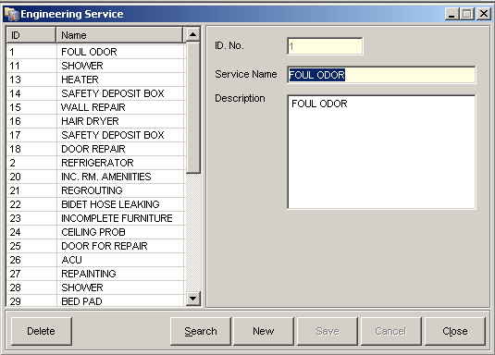
2
3
4
1
5
6
7
8
9
10

Figure II-23

- List of Engg. Services – enumerates all engg. services that the hotel has.
- ID No. field – holds the selected engg. service’s ID.
- Service Name field – displays selected engg. service’s name.
- Description field – displays selected engg. service’s description.
- Delete button – removes the selected engg. service from the list.
- Search button – searches for a specific engg. service in the list.
- New button – prepares the window for a new engg. service
entry.
- Save button – saves the new or modified engg. service.
- Cancel button – discards modification of or creation of engg. service information.
- Close button – closes the Engineering Service window.

? How to INSERT a New Engineering Service

  - From the Menu Bar, click Configuration then select Services and click Engineering Services. This will launch the Engineering Service window.
  - In the Engineering Service window, click the New button.
  - Enter engg. service ID, name and description in the appropriate fields at the right side of the screen. Engineering Service ID must be unique.
4. Click on Save button to save the new engineering service.
The engineering service will be added to the Engineering Service list.
5. Click on Cancel button to discontinue adding a new engineering service.

? How to EDIT Information of an Engineering Service

- In the Engineering Service window, select the engineering service you want to edit in the list by clicking it once. Then modify the necessary details (except Engineering Service ID: unique identifier of engineering service) at the right side of the screen.
- Click on Save button to save the changes. The engineering service will be updated in the list.
- Click on Cancel button to discard the changes.

? How to DELETE an Engineering Service

- In the Engineering Service window, select engineering service from the engineering service selection list and click the Delete button.
- Click on Yes button when prompted if you are sure you want to delete the service. The engineering service will be removed from the list.
3. Click on No button to cancel the deletion.

22. Privileges – records all privileges that guests may avail of in the hotel.
Location: Configuration -> Privileges
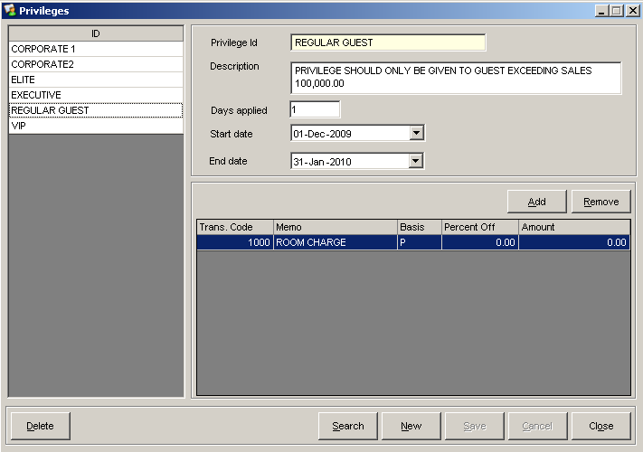
9
1
10
14
11
12
13
15
2
3
5
6
7
8
4

Figure II-24

- List of Privileges – enumerates all guest privileges that the hotel has.
- Privilege Id field – holds the selected privilege’s ID.
- Description field – displays the selected privilege’s description.
- Days applied field – displays the specific day/s during the guest’s stay that the privilege is applicable.
- Start date – displays the selected privilege’s first effective date.
- End date – displays the selected privilege’s last effective date.
- Add button - adds a transaction to be discounted in the selected privilege.
- Remove button – removes the selected transaction from the selected privilege.
- Privilege Discounts list – enumerates the transactions with discounts in the selected privilege.
- Delete button – removes the selected guest privilege from the list.
- Search button – searches for a specific privilege in the list.
- New button – prepares the window for a new privilege entry.
- Save button – saves the new or modified privilege.
- Cancel button – discards modification of or creation of privilege information.
- Close button – closes the Privileges screen.

? How to INSERT a New Privilege

  - From the Menu Bar, click Configuration then click Privileges. This will launch the Privileges window.
  - In the Privileges window, click the New button. Privilege Id must be unique.
  - Enter privilege ID, description, days applied, start and end date in the appropriate fields at the right side of the screen.

? How to Add a Privilege Discount
1. Click the Add button.
2. Click on the cell under Memo column. Select the transaction from the list of transactions.
3. Select the appropriate basis of discount (P - Percent or A - Amount) then input the value in the cell.
Privilege Discount will be added to the list

? How to Remove a Privilege Discount
1. Select privilege discount from the selection list, and click on Remove button.
Privilege Discount will be removed from the list.

4. Click on Save button to save the new privilege.
Click Ok when prompted that the entry was successfully added. The privilege will be added to the Privileges list.
5. Click on Cancel button to discontinue adding a new privilege.

? How to EDIT Information of an existing Privilege

1. In the Privileges window, select the privilege you want to edit in the list by clicking it once. Then modify the necessary details (except Privilege Id: unique identifier of a privilege) at the right side of the screen.
2. Click on Save button to save the changes.
Click Ok when prompted that the entry was successfully updated. The privilege will be updated in the list.
3. Click on Cancel button to discard the changes.

? How to DELETE a Privilege

- In the Privileges window, select the privilege from the privileges selection list and click the Delete button.
- Click on Yes button when prompted if you are sure you want to delete the privilege.

Click Ok when prompted that the entry was successfully deleted. The privilege will be removed from the list.
- Click on No button to cancel the deletion.

23. Hotel Promos – records all promos of the hotel.
Location: Configuration > Hotel > Promos
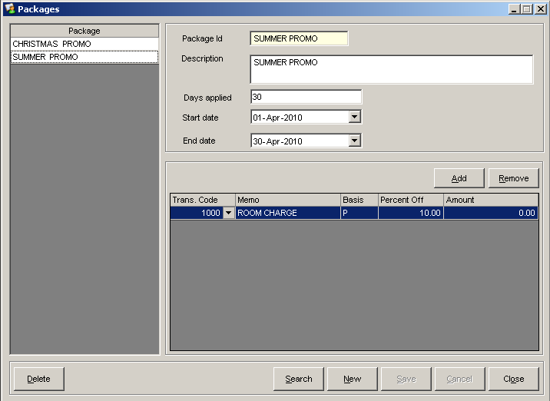
2
4
5
6
7
8
9
3
1
10
14
15
11
12
13

Figure II-25

- List of Hotel Promos – enumerates all promos that the hotel has.
- Package ID field – holds the selected promo’s ID.
- Description field – displays the selected promo’s description.
- Days Applied field – displays the specific day/s during the guest’s stay that the promo is applicable.
- Start Date calendar – displays the selected promo’s first effective day.
- End Date calendar – displays the selected promo’s last effective day.
- Add button – adds a transaction to be discounted in the selected promo.
- Remove button – removes the selected transaction from the selected promo.
- Promo discounts list – enumerates the transactions with discounts in the selected promo.
- Delete button – removes the selected promo from the list.
- Search button – searches for a specific promo in the list.
- New button – prepares the window for a new promo entry.
- Save button – saves the new or modified promo.
- Cancel button – discards modification of or creation of new promo information.
- Close button – closes the Packages window.

? How to INSERT a New Promo

- From the Menu Bar, click Configuration then select Hotel and click Promos. This will launch the Packages window.
- In the Packages window, click the New button.
- Enter promo details in the appropriate fields at the right side of the screen. Package Id must be unique.

? How to Add a Transaction
- Click the Add button.
- Select the transaction code from the Trans. Code drop down list.
- Select the appropriate basis of discount (P - Percent or A - Amount) then input the value in the cell.
Promo discount will be added to the list.
Note: Percent discount should not exceed 100% of the total percentage of each transaction.

? How to Remove a Transaction
  - From the list of transactions, select a transaction you want to remove.
  - Click the Remove button. Transaction will be removed from the list.

- Click on Save button to save the new promo.
Click the OK button when prompted that the entry was successfully added. The promo will be added to the Promo list.
- Click on Cancel button to discontinue adding a new promo.

? How to EDIT Information of an existing Promo

- In the Packages window, select the promo you want to edit in the list by clicking it once. Then modify the necessary details (except Package Id: unique identifier of the promo) on the right side of the screen.

To edit transactions, see “How to Add/Remove Transaction” in the previous part.
- Click on Save button to save the changes.
Click Ok when prompted that the entry was successfully updated. The promo will be updated in the list.
- Click on Cancel button to discard the changes.

? How to DELETE a Promo

  - In the Packages window, select promo from the promo selection list and click the Delete button.
  - Click on Yes button when prompted if you are sure you want to delete the promo. The promo will be removed from the list.
  - Click on No button to cancel the deletion.
Do you know that…
Days Applied field makes Hotel Promos flexible. You can have a promo such as “3 + 1” which means that for every a 3-night stay at the hotel, the 4th night is for free.

24. Housekeeper – records all hotel housekeepers of the hotel.
Location: Configuration > Services -> Housekeepers
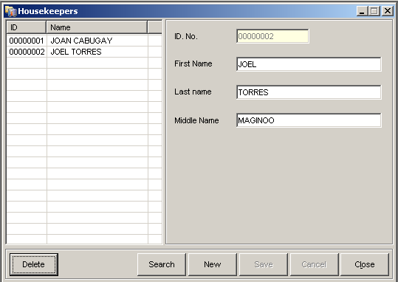
2
3
4
5
1
6
7
8
9
10
11

Figure II-26

- List of Housekeepers – enumerates all hotel housekeepers that the hotel has.
- ID No. text box – holds the selected housekeeper’s ID No.
- First Name text box – displays the selected housekeeper’s first name.
- Last Name text box – displays the selected housekeeper’s last name.
- Middle Name text box – displays the selected housekeeper’s middle name.
- Delete button – removes selected housekeeper from the list.
- Search button – searches for a specific housekeeper in the list.
- New button – prepares the window for a new housekeeper entry.
- Save button – saves the new or modified housekeeper.
- Cancel button – discards modification of or creation of housekeeper information.
- Close button – closes the Housekeepers window.

? How to INSERT a New Housekeeper

- From the Menu Bar, click Configuration then select Services and click Housekeepers. This will launch the Houser Keeper window.
- In the House Keeper window, click the New button.
- Enter the housekeeper ID and name. Housekeeper ID must be unique.
- Click on Save button to save the new housekeeper.
The housekeeper you saved will be added to the Housekeepers list.
- Click on Cancel button to discontinue adding a new entry.

? How to EDIT Information of a Housekeeper

- In the House Keeper window, select the housekeeper you want to edit in the list by clicking it once. Then modify the necessary details (except Housekeeper ID: unique identifier) at the right side of the screen.
- Click on Save button to save the changes.
The housekeeper will be updated in the list.
- Click on Cancel button to discard the changes.

? How to DELETE a Housekeeper

- In the House Keeper window, select the housekeeper from the housekeeper selection list and click the Delete button.
- Click on Yes button when prompted if you are sure you want to delete the housekeeper. The housekeeper will be removed from the list.
3. Click on No button to cancel the deletion.

25. Taxi Drivers – records all Taxi Drivers of the hotel.
Location: Configuration > Drivers
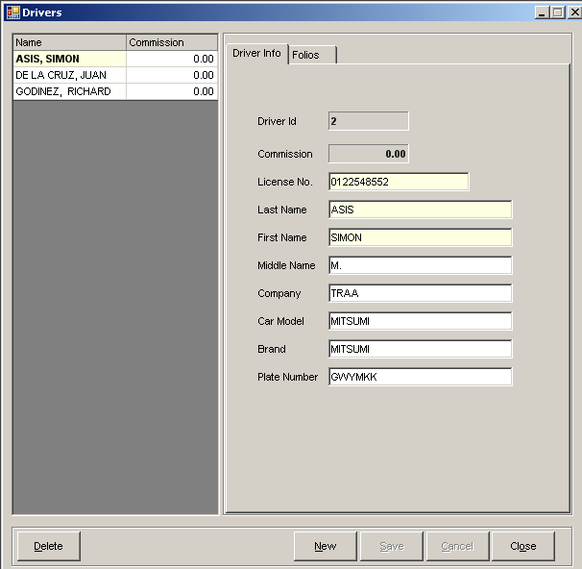
2
3
4
5
6
7
8
9
10
11
1
12
13
14
15
16

Figure II-27

- List of Drivers – enumerates all Taxi Drivers that the hotel has.
- Driver ID text box – displays the selected driver’s ID.
- Commission field – displays the selected driver’s total accumulated commission amount.
- License No. field – displays the selected driver’s license number.
- Last name field – displays the selected driver’s last name.
- First name field – displays the selected driver’s first name.
- Middle name field – displays the selected driver’s middle name.
- Company field – displays the selected driver’s company name.
- Car Model field – displays the car model of the selected driver.
- Brand field – displays the taxi brand of the selected driver.
- Plate Number field – displays the plate number of the taxi of the selected driver.
- Delete button – removes the selected driver from the list.
- New button – prepares the window for a new driver entry.
- Save button – saves the modified or new driver.
- Cancel button – discards modification of or creation of driver information.
- Close button – closes the Drivers window.

? How to INSERT a New Taxi Driver

  - From the Menu Bar, click Configuration then click Drivers. This will launch the Drivers window.
  - In the Drivers window, click the New button. Driver Id is automatically set by the system.
  - Enter driver information in the appropriate fields at the right side of the screen.
  - Click on Save button to save the new driver.
Click Yes when prompted to save new driver entry. The taxi driver will be added to the Drivers list.
5. Click on Cancel button to discontinue adding a new entry.

? How to EDIT Information of an existing Taxi Driver

1. In the Drivers window, select the driver you want to edit by clicking it once. Then modify the necessary details (except Driver Id: unique identifier of the driver) at the right side of the screen.
2. Click on Save button to save the changes.
Click Yes when prompted to save driver entry. The taxi driver will be updated in the list.
3. Click on Cancel button to discard the changes.

? How to DELETE a Taxi Driver

- In the Drivers window, select taxi driver in the selection list and click the
Delete button.
- Click on YES button when prompted if you are sure you want to delete the driver. The taxi driver will be removed from the list.
- Click on NO button to cancel the deletion.

26. Individual Guests – records all information about the guests of a hotel.
Location: Configuration > Guests > Individual

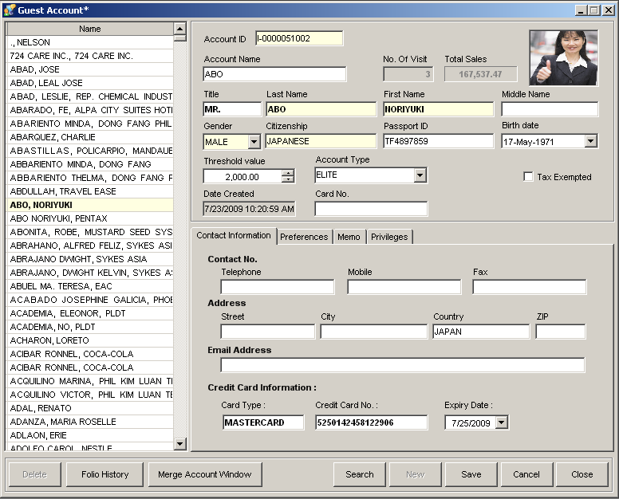
2
8
12
4
5
9
13
16
18
19
21
22
23
1
24
25
26
27
28
29
30
31
3
7
11
20
15
17
10
14
6

Figure II-28

- List of Guests – enumerates all guest accounts that the hotel has.
- Account ID – holds the selected guest’s account ID.
- Account Name field – displays the selected guest’s account name.
- No. of Visit field – displays the selected guest’s number of stays in the hotel.
- Total Sales field – displays the selected guest’s total sales.
- Guest Image – displays the selected guest’s image.
- Title field – displays the selected guest’s title or distinction.
- Last name field – displays the selected guest’s last name.
- First name field – displays the selected guest’s first name.
- Middle name field – displays the selected guest’s middle name.
- Gender filed – displays the selected guest’s gender.
- Citizenship field – displays the selected guest’s citizenship.
- Passport ID – displays the selected guest’s Passport ID; this should be filled out if the guest is a non-resident of the country.
- Birth Date – displays the selected guest’s birth date.
- Threshold Value field – displays the maximum amount the selected guest can be charged.
- Account Type field – displays the selected guest’s account type.
- Date Created – displays the date and time the selected account was created.
- Card No. field – displays the guest’s privilege card number if the guest has one.
- Tax Exempted box – shows if the guest is exempted from tax or not.
- Contact Information tab – displays the selected guest’s contact information.
- Preferences tab – displays the selected guest’s preferences in rooms, foods, etc.
- Memo tab – displays other notes/information of a guest.
- Privileges tab – displays list of privileges a guest has.
- Delete button – removes selected guest account.
- Folio History button – displays history of guest’s visit to the hotel.
- Merge Account button – merges account to another account.
- Search button – search for a specific guest account.
- New button – prepares the screen for a new guest account.
- Save button – saves the new or modified guest account.
- Cancel button – discards modification of or creation of guest information.
- Close button – closes the Guest Account window.

? How to INSERT a New Guest Account

  - From the Menu Bar, click Configuration then select Guests and click Individual. This will launch the Guest Account window.
  - In the Guest Account window, click the New button. Account ID is automatically set by the system.
  - Enter name, citizenship and other necessary details in the appropriate fields at the right side of the screen.

? How to Add a Privilege
- Select Privilege tab and click on the Add button. The privileges window will be displayed.
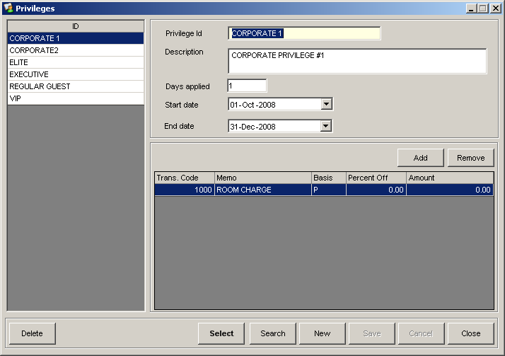

Figure II-29
2. Select a privilege from the list and click Select button.
3. To add more privileges, repeat step 2. Click Close button.
The privilege will be added to the Guest Account Privilege list.

? How to Remove a Privilege
- Select Privilege tab.
- Select from the list of privileges and click the Remove button.
Privilege will be removed from the list.

4. Click on Save button to save the new guest account.
5. Click on Cancel button to discontinue adding a privilege.

? How to EDIT Information of an existing Guest Account

1. In the Guest Account window, click on the guest you want to edit from the list then modify the necessary details (except Account ID: unique identifier of the guest) at the right side of the screen.

2. Click on Save button to save the changes.
Click Ok when prompted that the account was successfully updated. The guest account will be updated in the list.

3. Click on Cancel button to discard the changes.
? How to DELETE a Guest Account

- In the Guest Account window, the select guest account from the selection list and click the Delete button.
- Click on Yes button when prompted if you are sure you want to delete the account. The guest account will be removed from the list.
- Click on No button to cancel the deletion.
Do you know that…

You can view a larger guest’s image by pointing your cursor over the guest image box.
If you supply a guest’s Credit Card Information, it will be automatically shown and used once the guest pays via Credit Card.

27. Group Guests – records all Company Accounts of the hotel.
Location: Configuration > Guests > Group
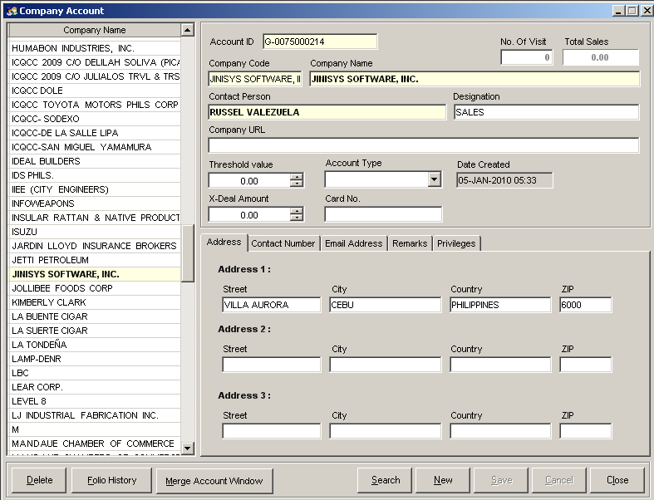
11
12
14
16
17
18
19
1
5
7
9
10
13
15
20
21
22
23
24
25
26
27
3
6
2
8
4

Figure II-30

- List of Company Accts. – enumerates the hotel’s active Company Accounts.
- Account ID field – holds the selected company’s account ID.
- No. of Visit field – displays the selected company’s number of stays in the hotel.
- Total Sales field – displays the selected company’s total sales.
- Company Code field – displays the selected company’s code.
- Company Name field – displays the selected company’s name.
- Contact Person field – displays the selected company’s contact person.
- Designation field – displays the designation of the selected company’s contact person.
- Company URL field – displays the company’s website URL.
- Threshold Value field – displays the maximum amount the selected company can be charged.
- Account Type field – displays the selected company’s account type.
- Date Created – displays the date and time the selected account was created.
- X-Deal amount field – displays the X-Deal amount the selected company and the Hotel has agreed upon.
- Card No field – displays the selected company’s privilege card number if it has one.
- Address tab – contains selected company’s address.
- Contact Number tab – contains selected company’s contact number.
- Email Address tab – contains selected company’s email addresses.
- Remarks tab – contains other information/remarks regarding the
selected company.
- Privileges tab – contains selected company’s privileges.
- Delete button – removes selected company’s account from the list.
- Folio History button – displays selected company’s Folio history.
- Merge Account button – merges the selected account with another account.
- Search button – searches for a specific company account in the list.
- New button – prepares the screen for a new Company Account.
- Save button – saves the new or modified company account.
- Cancel button – discards modification of or creation of company information.
- Close button – closes the Company Account window.

? How to INSERT a New Company Account

  - From the Menu Bar, click Configuration then select Guests and click
Group. This will launch the Company Account window.
  - In the Company Account window, click the New button. Account ID is automatically set by the system.
  - Enter company name, contact person and other necessary details in the appropriate fields at the right side of the screen.

? How to Add a Privilege
- Select Privileges tab and click on the Add button. The privilege window will be displayed.

Figure II-31
- Select a privilege from the list and click Select button.
- To add more privileges, repeat step 2. Click Close button.
The privilege will be added to the Company Account Privilege list.

? How to Remove a Privilege
- Select Privileges tab.
- Select from the list of privileges and click the Delete button.
Privilege will be removed from the list.

4. Click on Save button to save the new company account.
5. Click on Cancel button to discontinue adding a new entry.

? How to EDIT Information of an existing Company Account

1. In the Company Account window, click on the account you want to edit from the list then modify necessary details (except Account ID: unique identifier of the account) at the right side of the screen.

2. Click on Save button to save the changes.
Click Ok when prompted that the account was successfully updated. The company account will be updated in the list.

3. Click on Cancel button to discard the changes.

? How to DELETE Company Account

- In the Company Account window, select the guest account in the selection list and click the Delete button.
- Click Yes when prompted if you are sure you want to delete the account. The company account will be removed from the list.
- Click on No button to cancel the deletion.

28. User Roles – records the different roles of the system users of the hotel.
Location: Configuration > Hotel > System Roles
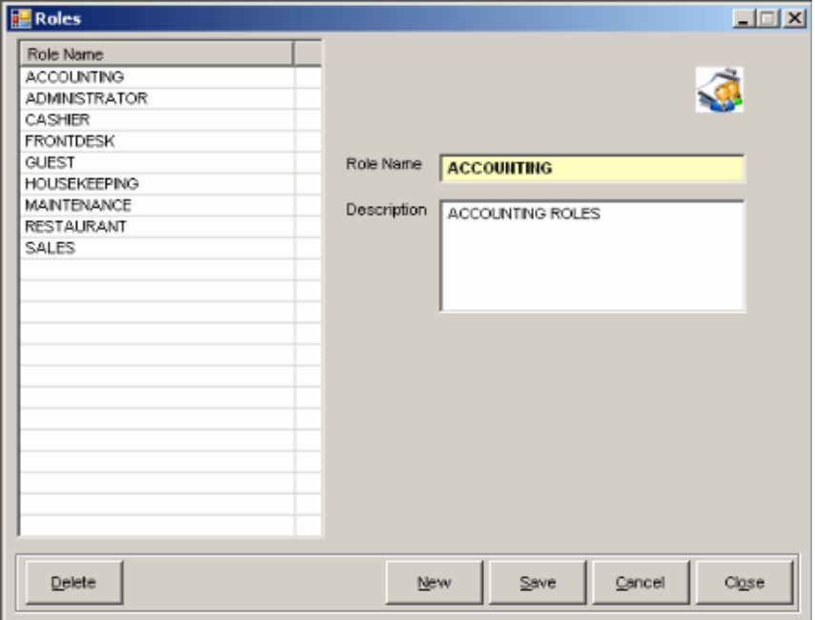
1
2
3
4
6
7
8
5

Figure II-32

- List of Roles – enumerates all user uoles of the hotel.
- Role Name text box – holds the selected role’s name.
- Description text box – displays the selected role’s description.
- Delete button – removes the selected role.
- New button – prepares the screen for a new role.
- Save button – saves the new or modified role.
- Cancel button – discards modification of or creation of role information.
- Close button – closes the User Roles window.

? How to INSERT a New User Role

  - From the Menu Bar, click Configuration then select Hotel and click System Roles. This will launch the Roles window.
- In the Roles window, click the New button. Enter role name and description in the appropriate fields at the right side of the screen. Role Name must be unique.
- Click on Save button to save the new user role.
- Click on Cancel button to discontinue adding a new entry.

? How to EDIT Information of an existing User Role

1. In the Roles window, select the role you want to edit in the list by clicking it once. Then modify necessary details (except Role Name: unique identifier of the user role) at the right side of the screen.
2. Click on Save button to save the changes.
3. Click on Cancel button to discard the changes.

? How to DELETE a User Role

- In the Roles window, select role from the user role selection list and click the Delete button.
- Click on YES button when prompted if you are sure you want to delete the role. The user role will be removed from the list.
- Click on NO button to cancel the deletion.

29. System Users – records all information regarding the users of the system.
Location: Configuration > Hotel > System Users
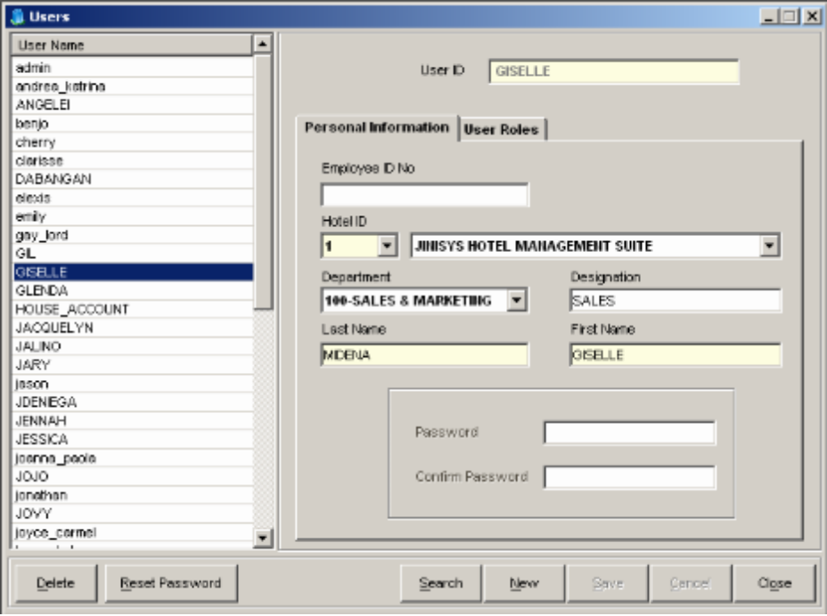
12
13
14
15
16
17
18
1
5
7
9
2
3
4
6
8
11
10

Figure II-33

- List of Users – enumerates all user accounts that the hotel has.
- User ID field – holds the selected user’s ID.
- User Roles tab – contains a list of roles the selected user has.
- Employee ID field – displays the selected user’s employee ID.
- Hotel ID field – displays the selected user’s hotel ID.
- Hotel Name field – displays the hotel name the selected user is assigned to.
- Department field – displays the selected user’s department.
- Designation field – displays the selected user’s department designation
- Last name text box – displays the selected user’s last name.
- First name text box – displays the selected user’s first name.
- Password box – allows setting of passwords with confirmation.
- Delete button – removes the selected user from the list.
- Reset Password button – resets the selected user’s current password.
- Search button – searches for a specific user account in the list.
- New button – prepares the window for a new user account.
- Save button – saves the new or modified user account.
- Cancel button – discards modification of or creation of user information.
- Close button – closes the User Account window.

? How to INSERT New User Account

  - From the Menu Bar, click Configuration then select Hotel and click System Users. This will launch the Users window.
  - In the Users window, click the New button.
  - Enter user ID, name and other necessary details in the appropriate fields at the right side of the screen. User ID must be unique.

? How to Add Roles
- Select User Roles tab and click on the Add Role button.
- Select a role to add from the Role drop down list.
- To add more roles, repeat step 2.

? How to Remove Roles
- Select User Roles tab.
- Select the role/s to delete from the list and click the Remove Role button.

4. Click on Save button to save the new user.
Click the OK button when prompted that the entry was successfully added. The user account will be added to the User Account list.

5. Click on Cancel button to discontinue adding a new entry.

? How to Reset Password of User Account

      - Click on the Reset Password button.
      - Enter new password and confirm the password you inputted.

? How to EDIT Information of an existing User Account

  - In the Users window, select the user you want to edit by clicking it once. Then modify necessary details (except User ID: unique identifier of the user account) at the right side of the screen.
  - Click on Save button to save the changes.
Click Ok when prompted that the entry was successfully updated. The user account will be updated in the list.
  - Click on Cancel button to discard the changes.
? How to DELETE a User Account

- In the Users window, select the user account from the selection list and click the Delete button.
- Click Yes when prompted if you are sure you want to delete the account. The user account will be removed from the list.
3. Click on NO button to cancel the deletion.

- System Configuration – records all configurations of the system, e.g. default breakfast value, default cash terminal.
Location: Configuration > Hotel > System Configuration
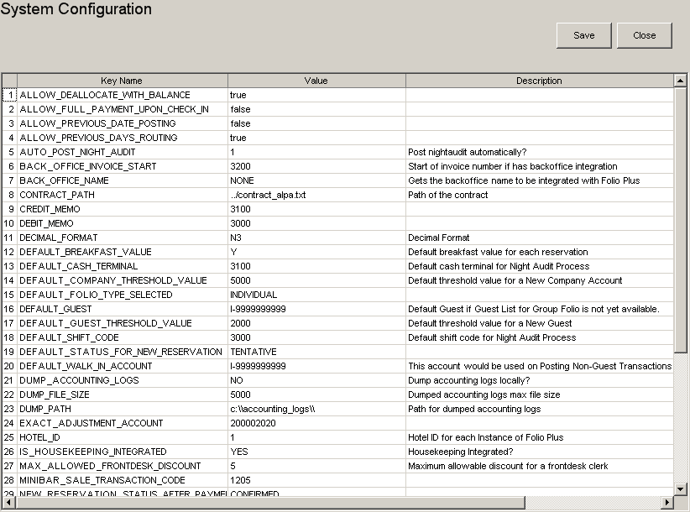
1
2
3

Figure II-34

- List of Configurations – enumerates all system configurations with their
values.
- Save button – saves all changes to configurations.
- Close button – closes the System Configuration window.

? How to EDIT Information of a System Configuration

1. In the System Configuration window, select a Configuration from List of Configurations, and modify its information.
2. Click on Save button to save the changes.
Click Ok when prompted that the entry was successfully updated. The configuration will be updated in the list.
3. Click on Close button to close the window.

III. BASIC TRANSACTIONS

  - Check-In through Walk-In

? Check-In using the Room Status

- Select an available room in the Room Status window.
- Double-click the room. The Individual Reservation screen will appear.
- Enter details of the guest’s stay.
- Click on the Save button.
The system will automatically save the reservation and set its status to Checked-In.

  - Check-In through a Reservation
There are three ways to check in a reservation: through the Guest List, Folio and Room Status. The steps for each method are discussed further below.

? Check-In using the Guest List
Location: Transaction > Frontdesk > Guests List

- In the Guest List screen, select Confirmed on the Status drop down list.
- Select a reservation to be checked-in by clicking it from the list and click the Check-In button.
- Select Yes when prompted if you are sure you want to check-in the selected reservation.
Click OK when prompted that the transaction was successful. The reservation will be updated to Checked-in. Also, the guest’s room status color will be changed from blue to sky blue.
- Click on NO button to discontinue the process.

? Check-In by viewing the Folio

        - Select a reservation from Guest List under Confirmed status.
        - Double-click to view guest's Reservation screen, and click Check-In button.
        - Click Yes when prompted if you are sure you want to check-in the selected reservation.

Guest’s status is now checked-in.
        - Click on NO button to cancel the action.

? Check-In using the Room Status

- In the Room Status window, select the reserved room then right click on it, and click View Reservation Info from the options enumerated.
Guest’s Reservation screen will appear. If guest’s status is Tentative, click Confirm button to enable the Check-In button.
- Click on the Check In button.

Status of the folio will now be Checked-In.
Note: Only confirmed reservations for the current day can be checked-in.

3. Single Reservation – creates a new Individual Reservation.
Location: Transactions > Frontdesk > Single Reservation

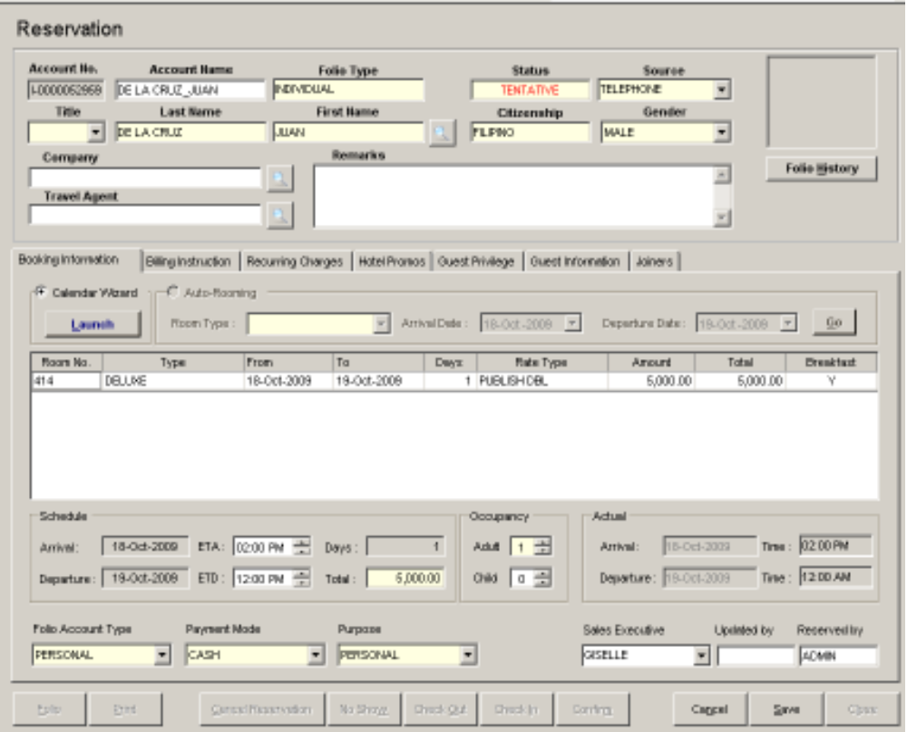
1
2
3
4
8
5
9
10
11
13
14
15
16
17
18
19
20
21
6
7
22
12

Figure III-1

- Folio Information box – contains general information on the reservation.
- Calendar Wizard box – launches the Room Calendar for easy room selection.
- Schedule grid – displays schedule information like room number, type, date range, rate type, etc.
- Schedule box – displays the expected arrival and departure dates and times of the folio
- Occupancy box – displays the number of occupants included in the folio.
- Actual Schedule box – displays the actual departure and arrival of the folio.
- Auto-Rooming box – allows the automatic selection of an available room based on the room type and schedule indicated.
- Folio Account Type – displays the folio’s account type.
- Payment Mode – displays the payment type that will be used.
- Purpose drop down box – displays the purpose of the guest for staying in the hotel.
- Sales Executive – displays the account’s Sales Executive.
- Reserved by field – displays the user who made the reservation.
- Folio button – shows the account’s Folio Ledger.
- Print button – prints the guest’s Folio.
- Cancel Reservation – cancels the reservation.
- No Show button – cancels the reservation and sets the cancellation reason to No Show.
- Check Out button – sets the status of the folio to Checked Out.
- Check In button – sets the status of the folio to Checked In.
- Confirm button – confirms the reservation.
- Cancel button – discards modification of or creation of reservation information.
- Save button – saves the new or modified reservation.
- Close button – closes the Individual Reservation window.

? How to Make a Single Reservation

  - From the Menu Bar, click Transactions then select Frontdesk and click Single Reservation. This will launch the Reservation screen.
  - In the Reservation window, input the guest information. For returning guests, just type a few characters in the Last Name field then double click the field. Select the guest from the list shown; the guest information will be filled out.
Note: Make sure that the required fields are not left blank.

3. Add the room schedule manually or by using the Calendar Wizard.
? How to Add a Room Schedule Manually
      - In the Booking Information tab, type the room number that the guest wants under the Room No. column. See steps below.
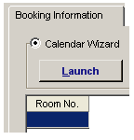
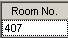

1.2 Type the desired room number. Room must be vacant-clean. Then hit ENTER key on the keyboard.

Figure III-2
1.1 Click on this cell.

      - Room information will be displayed in the schedule grid.
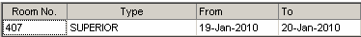
Figure III-3

? How to Add a Room Schedule using the Calendar Wizard
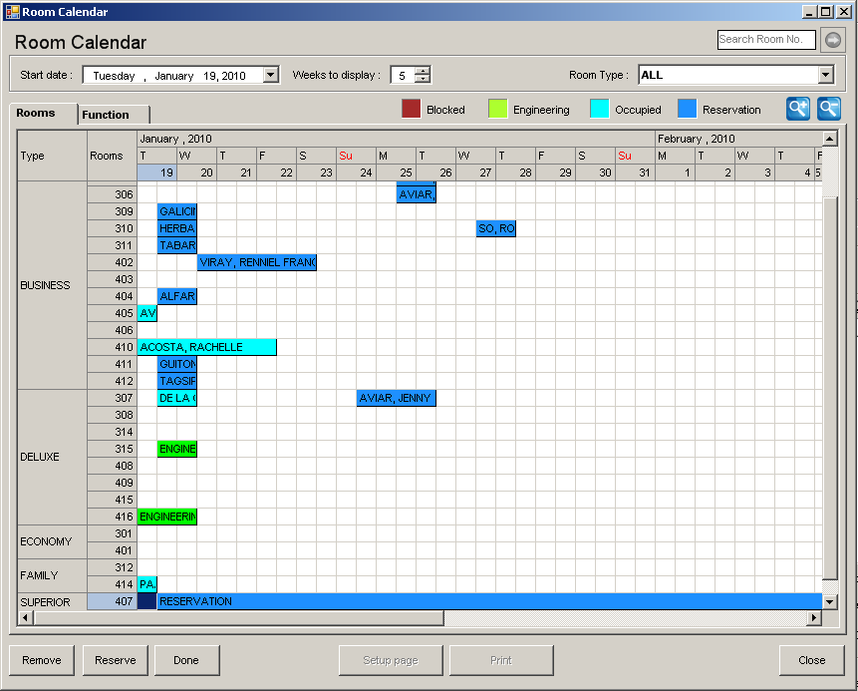
- In the Booking Information tab, click on Calendar Wizard radio button then click on the Launch button. The Room Calendar window will open.
Types of Room and specific room numbers

Editing Area

Figure III-4
- Select the room type and room number that the guest wants to occupy.
  - Click the arrival date on the room number.
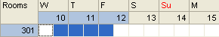
Figure III-5
  - Hold and drag the mouse to the specified departure date. Notice that the boxes are colored blue as you drag the mouse, which reflects the dates on the upper row.
- Click the Reserve button. The blocks will be marked “RESERVATION”.
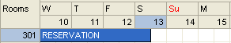
Figure III-6
- Once done, click on Done button. Room number and booking date will appear in the schedule grid.

? How to Add a Room Schedule using Auto-Rooming
                - In the Booking Information tab, click on Auto-Rooming button. The auto-rooming options will be enabled.
                - Select room type, arrival date and departure dates.
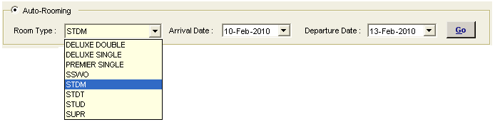

Figure III-7
                - Click on the Go button.
Click Ok when prompted to continue selecting the room chosen by the system. Room number and booking date will appear in the schedule grid.
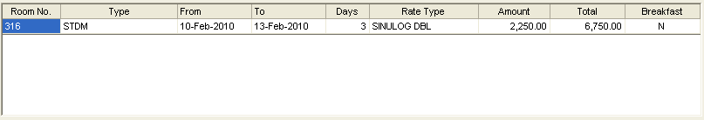

Figure III-8
4. Click on Save button to save the new reservation.
5. Click on Cancel button to discard the entry.
Do you know that…

You can add multiple room schedules by right clicking on the schedule grid and selecting Add Schedule.

To delete schedule, right click on the selected schedule, and select Delete Schedule.

Note: Only the selected room’s schedule can be modified.

? How to Add/Remove Room Billing Instructions
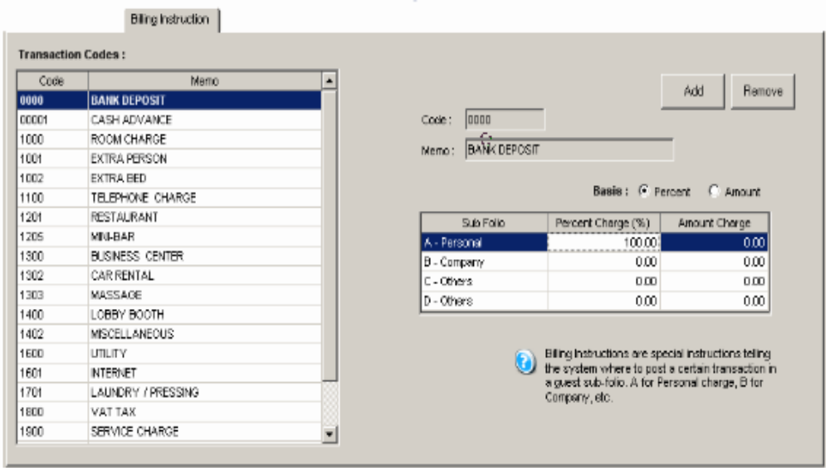

Transaction Codes

Figure III-9

- In the Reservation window, select the Billing Instruction tab. It holds all the transaction codes at the left side of the screen; at the right are the sub-folios with their corresponding charges.
- To add a billing instruction for a transaction, select a transaction from the list of transaction codes.
- Select the basis for transferring the amount – Percentage or Amount.
- Enter the value to be distributed to each sub-folio. If percentage is selected, total percentage of all sub-folios should be 100%.
- Click on the Add button. If the instruction is successfully added, the transaction will be highlighted in pink.
- To remove a billing instruction, select the transaction from the list then click on the Remove button.
- Click on Save button.
Do you know that…

Billing Instructions direct the system how to distribute the charges of certain transactions incurred by a guest among his/her sub-folios. This is useful when different parties are paying for a guest’s account.

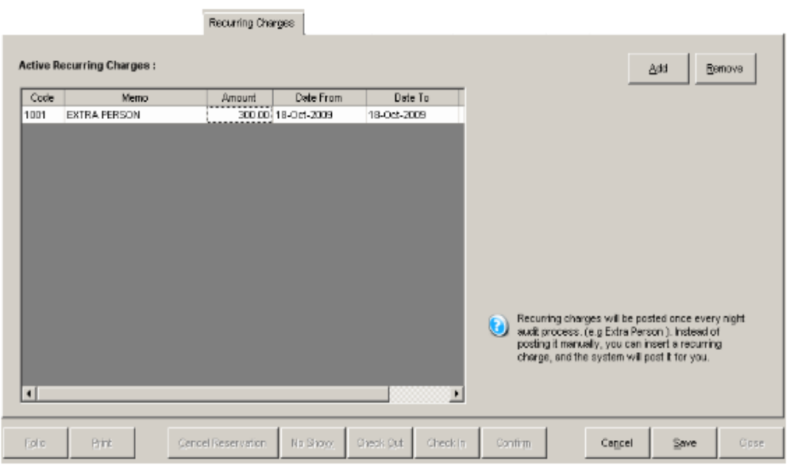
? How to Add/Remove a Recurring Charge

Figure III-10
- In the Reservation window, select the Recurring Charges tab. Click on the Add button. Transaction Codes List window will appear.
- Select a transaction by clicking it, then click Select button.
- Click on the Close button.

Selected transaction/s is/are shown in the recurring charges grid.
- Enter the charge amount and the date range to post the transaction.
- To remove a recurring charge, just select the transaction from the list then click on the Remove button.
- Click on Save button.
Do you know that…

Recurring charges are automatically posted by Folio Plus to the guest’s folio. All you have to do is select the charges and specify their corresponding date range and amount.

? How to Add/Remove a Hotel Promo
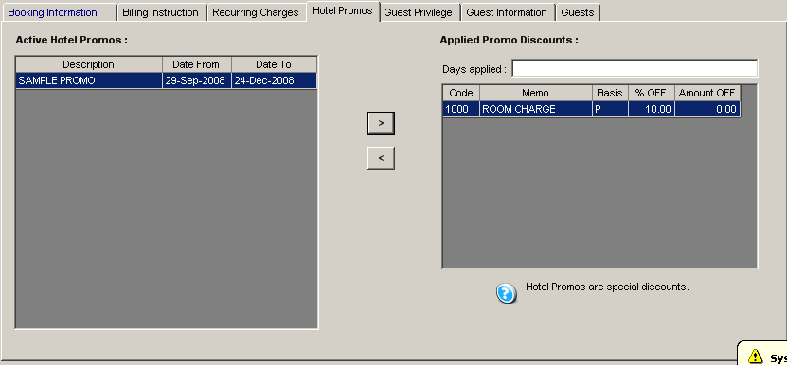

Figure III-11
- From the Reservation window select the Hotel Promos tab. Active hotel promos will appear at the left side of the screen; at the right are applied promo discounts.
- Select a promo from the list of active hotel promos, and then click on the “less than” symbol (>).
Note: Only one promo is applicable to a folio. If a guest has more than one privilege, the higher discount rate will prevail.
- To remove an applied promo, select it from the Applied Promo Discounts list then click on the “greater than” symbol (<).
- Click on Save button.
Do you know that…

Hotel Promos are special discounts of the hotel given to guests in a specific period; promos will only appear in the guest’s folio when occupancy date is within the promo period.

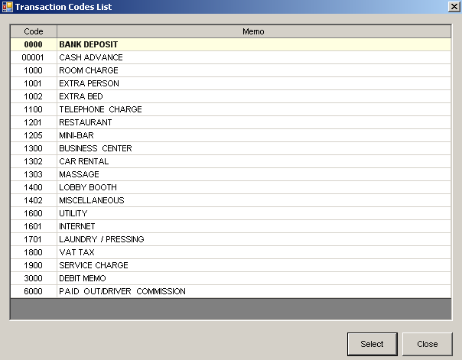
? How to Add/Remove a Guest Privilege

Figure III-12a
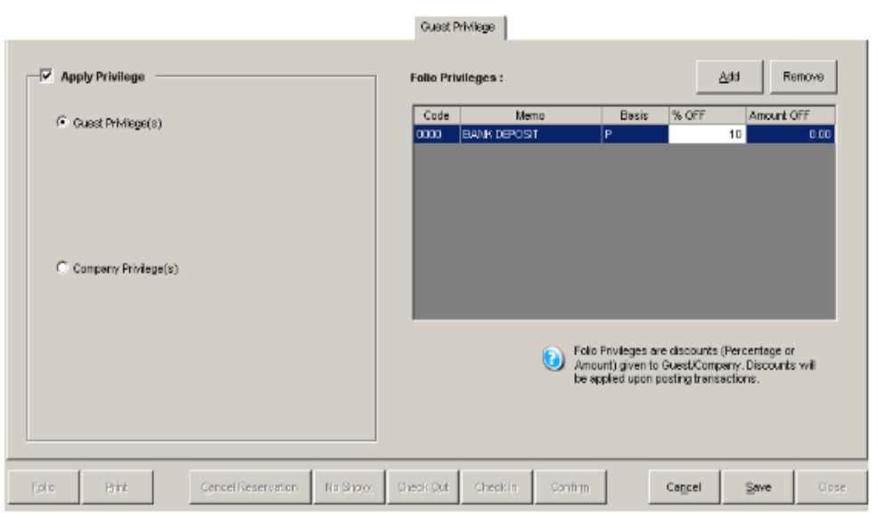

Figure III-12b

- From the Reservation window select the Guest Privilege tab.
- Check the Apply Privilege check box.
- Click on Guest Privilege button for individual type of guest. System will automatically display the guest’s privileges in the list of privileges; click on Company Privilege button for individual guest associated with company. System will automatically display the company’s privileges.
- To add a privilege, just click on the Add button. A window with a list of transactions will be displayed (Figure III-12a). Select a transaction that will be discounted.
- Once you’re done, close the window. Folio Privileges list will display all those selected transactions (Figure III-12b). Enter the details of the privilege such as basis of discount – P for percentage and A for amount, and the value. If percentage is selected, it should not be greater than 100.
- To remove a privilege, just select it from the list then click on the Remove button.
- Click on Save button.

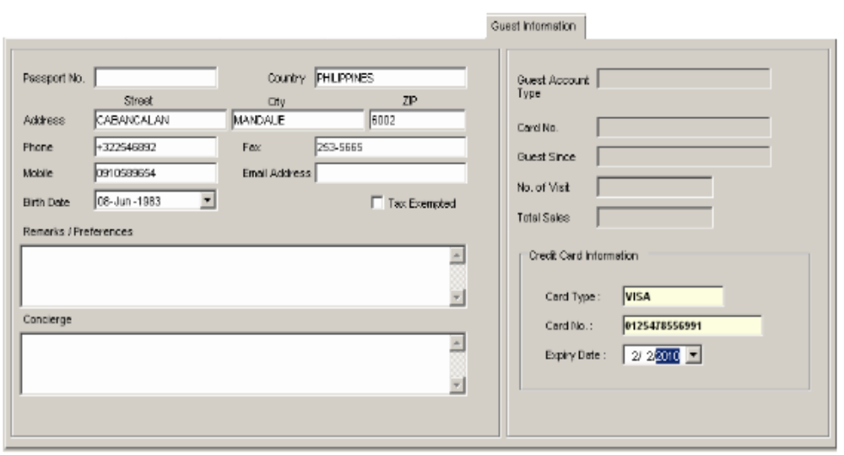
? How to Add Guest Information

Figure III-13
            - Select Guest Information tab.
            - Provide the necessary information on the guest like address, passport #, contact details, etc.
            - Click on Save button.
Do you know that…

If you supply a guest’s Credit Card Information, it will be automatically shown and used once the guest pays via Credit Card.

? How to Add/Remove Joiners
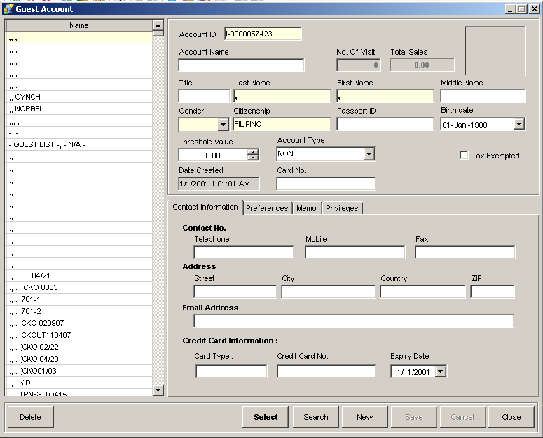

Figure III-14
- Select the Joiners tab, and click on the Add button. The Individual Account window will appear (Figure III-14).
- From the list, select the guest to be added and click on Select button. If the guest’s name is not in the list, click on the New button, and fill out the necessary fields (e.g. Lastname, Firstname, Gender, Citizenship etc.). Then, click on Save button.
- A confirmation box will prompt you asking if you would like to add another guest. Selecting No will redirect to the joiners tab, displaying the newly added guest; selecting Yes will allow for the selection of another guest.
- Selected guest/s is/are now listed in the list of guests (Figure III-23 on page 95). Number of adult pax will be updated as well.
- To remove a joiner, simply select him/her from the list then click on the Remove button.
- Click on Save button.

            - Group Reservation – creates a new Group Reservation.
Location: Transactions -> Frontdesk -> Group Reservation (F7)
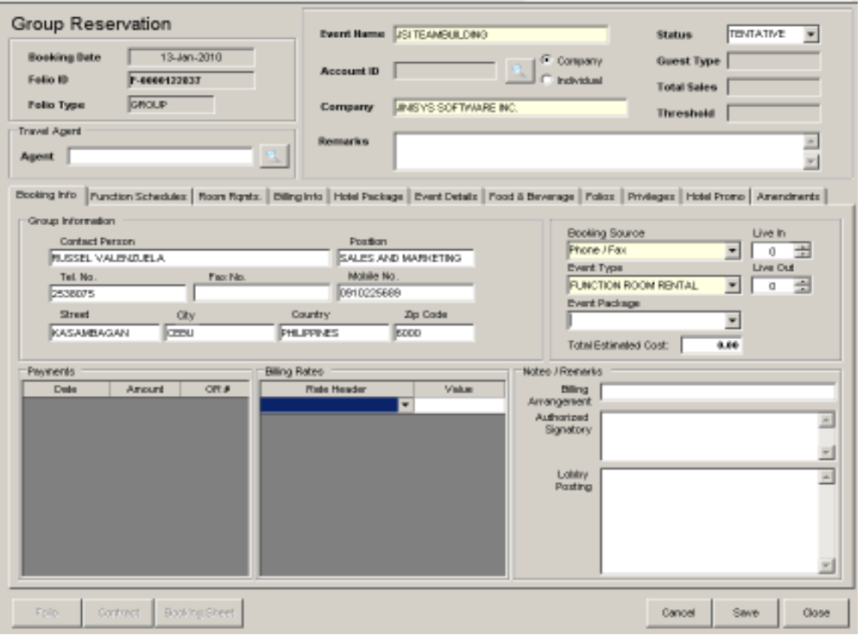
4
5
6
7
8
9
1
2
3

Figure III-15

        - Account Information – displays booking date, Folio ID and type.
        - Travel Agent field – displays the account’s travel agency or agent.
        - Reservation Info – displays reservation details like event name, remarks, status etc.
        - Folio button – displays the guest’s folio window.
        - Contract button – displays a printable form containing the reservation information that will be used as the contract.
        - Booking Sheet button – displays the reservation requirements categorized by department.
        - Cancel button – discards modification of or creation of reservation information.
        - Save button – saves the new or modified reservation entry.
        - Close button – closes the Group Reservation window.

? How to Make a Group Reservation

          - Click the New Reservation button in Group Reservations List window. Group Reservation window will open.
          - Input the event name; do not include apostrophe to avoid errors.
          - Select the folio type (Company/Individual) by clicking on the corresponding button, and type the name on the field provided. Include remarks if necessary.

? How to Add Booking Information
                - Select Booking Info tab.
                - Enter the contact details. Contact details are optional but they help the user confirm the reservation through the information given.
                - Select the booking source and event type. These are required information and must not be left blank.
                - Select event package from the drop down list if necessary. After selection, the Live In & Out fields are set to a value depending on the package selected. Event Package will appear in the Hotel Package tab.
                - Provide the details under Notes/Remarks if necessary. The information will be used for the event contract.
                - Choose the header rate and input its value on the appropriate fields if necessary.
Note: Occupancy header rates will be applied to child folios having “Applied” rate types; Live-In and Live-Out header rates corresponding to a meal type (e.g. AM Snacks Live In) will be used in computing the total amount regardless of the menu selected.
                - Once done, click Save button.

? How to Add/Remove Function Schedules
                - From the Group Reservation window, select Function Schedules tab.
                - Click Add Schedule button.
Note: User can add multiple schedules.
                - Select the room number, date range, start-end time, rate type, amount, etc.
                - To remove a schedule, select it from the list and click Remove button.
                - Once done, click Save button.

? How to Block Rooms as Room Requirements
                - From the Group Reservation window, select Room Requirements tab.
                - Click Edit Info button.
                - Select the From-To dates in the Calendar box.
                - Input No. of Rooms and/or Pax on the corresponding room. Hit Enter key on the keyboard. The rows will be colored red.
                - Block rooms manually or automatically.

? How to block rooms manually
                - Click the row highlighted in red to let the calendar wizard filter the rooms according to its type.
                - Click Block Rooms button. Calendar wizard will open, from there, select the room/s based on the requirements.
                - Close the Calendar Wizard window. The blocked rooms will be displayed under Blocked Rooms section.

? How to block rooms automatically
                - Click Auto-Block Rooms button. Group Blocking window will show.
                - Select From-To dates, and click Show Vacant button. Vacant rooms with their type will be displayed.
                - Click Block button. Click Ok when prompted that the blocking is successful. System will return to Group Blocking window.

                - Once done, click the Close button. The blocked rooms will be displayed under Blocked Room section.

? How to Add/Remove Billing Information
            - From the Group Reservation window, select the Billing Information tab. It holds all the transaction codes at the left side of the screen; at the right are the sub-folios with their corresponding charges.
            - To add a billing instruction for a transaction, select the transaction from the list of Transaction Codes.
            - Select the basis for transferring the amount – Percentage or Amount.
            - Enter the value to be distributed to each sub-folio. If percentage is selected, total percentage of all sub-folios should be 100%.
            - Click on the Add button. If the instruction is successfully added, the transaction will be highlighted in pink.
            - To remove a billing instruction, select the transaction from the list then click on the Remove button.
            - Once done, click Save button.
Do you know that…

Billing Instructions direct the system how to distribute the charges of certain transactions incurred by a guest among his/her sub-folios. This is useful when different parties are paying for a guest’s account.

? How to Add Hotel Package
            - From the Group Reservation window, select Hotel Package tab. It will display all the transaction codes.
            - To add an inclusion to the package, select a transaction from the list of Transaction Codes. Click the arrow pointing to right. To remove, click the arrow pointing to the left.
            - Once done, click Save button.

? How to Add Event Details
            - From the Group Reservation window, select Event Details tab.
            - Select the requirement type from Requirement Type drop down list.
            - Check the corresponding boxes of the details to be added, and click the arrow pointing to right. To remove, select the requirement at the left side and click arrow pointing to the left.
            - Once done, click Save button.

? How to Add Food & Beverage for the event
            - From the Group Reservation window, select Food & Beverage tab.
            - Select the date from the list under Meal Dates. If the desired date is not found, click Add Date button and input the date.
            - Click New Meal button, and select the meal type from the Meal Type drop down list.
            - Provide the ready and deliver times, no. of pax (live-in and/or live out), amount, venue, etc.
            - Select a menu from the Available Menus drop down list.
            - Click Add Menu button to add the item. To remove an item, select it and click Remove Menu button.
            - Click Save Meals button. The meal type will be shown under the date selected.
            - Once done, click Save button.

? How to Add Reservation Information on Child Folios
            - From the Group Reservation window, select Folios tab. It will display the blocked rooms set in Room Rqts tab.
            - Double-click on a room to open its Reservation window.
            - Input the reservation details. The booking information may be updated except for the room number.
            - Click Save button on the Reservation window. The System will return to the group reservation screen. The selected row will be colored blue indicating that it is assigned to a folio; its status will be “Confirmed.”
            - Once done, click Save button.

? How to Add/Remove Privileges
            - From the Group Reservation window, select Group Privileges tab.
- Check the Apply Privilege check box.
- Click on Guest Privilege button for individual type of guest. System will automatically display the guest’s privileges in the list of privileges; click on Company Privilege radio button for individual guest associated with company. System will automatically display the company’s privileges.
- To add a privilege, just click on the Add button. A window with a list of transactions will be displayed. Select a transaction that will be discounted.
- Once you’re done, close the window. Folio Privileges list will display all those selected transactions. Enter the details of the privilege such as basis of discount – P for percentage and A for amount, and the value. If percentage is selected, it should not be greater than 100.
- To remove a privilege, just select it from the list then click on the Remove button.
- Once done, click Save button.

? How to Apply Hotel Promos

- From the Group Reservation window, select the Hotel Promos tab. Active hotel promos will appear at the left side of the screen; at the right are applied discounts.
- Select a promo from the list of active hotel promos, and then click on the “less than” symbol (>).
Note: Only one promo is applicable to a folio. If a guest has more than one privilege, the higher discount rate will prevail.
- To remove an applied promo, select it from the Applied Promo Discounts list then click on the “greater than” symbol (<).
- Click on Save button.
Do you know that …

Hotel Promos are special discounts of the hotel given to guests in a specific period; promos will only appear in the guest’s folio when occupancy date is within the promo period.

? How to Add an Amendment
            - Select Amendments tab, and click New button.
            - Enter the amendment details.

? How to Remove an Amendment
1. Select amendment on the list, and press DELETE button on the keyboard. A confirmation box will prompt. Click Yes to proceed.

3. Once done, click Save button. Newly added amendment will be shown in the list of amendments. To print the amendments, click Print Amendments button.

5. Guest List – displays all guests that are checked-in, reserved, etc.
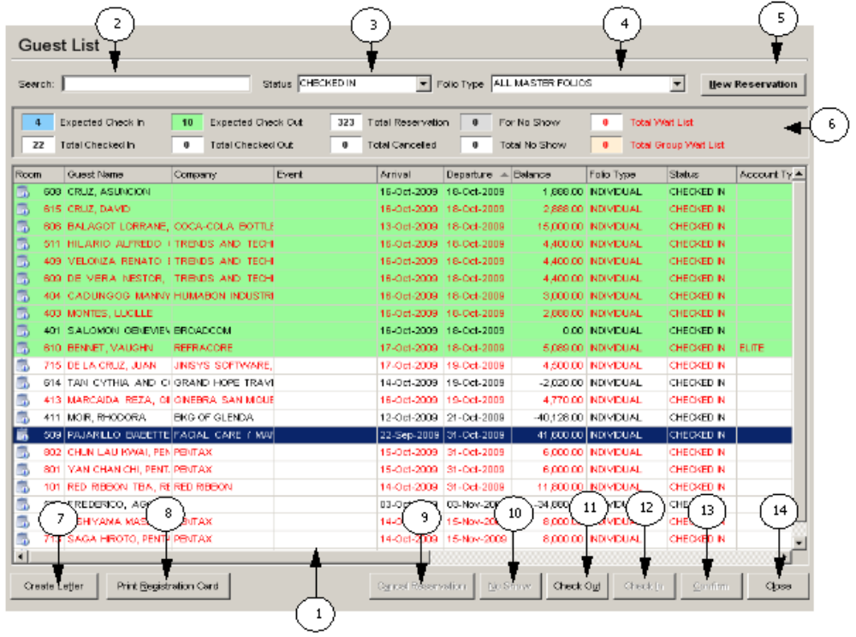
Location: Transactions > Frontdesk > Guest List

Figure III-16
2
3
4
5
6

- List of Guests – enumerates all guests of the hotel filtered by their status. Default is status is “Checked In.”
- Search field – field for entering the search word for searching a specific guest.
- Status field – field for selecting status of guests to be displayed.
- Folio Type field – field for selecting folio type of guests to be displayed.
- New Reservation button – prepares the window for an Individual Reservation.
- Guest Count field – displays the total number of guests per status.
- Create Letter button – creates a letter for a high balanced guest.
- Print Registration Card button – prints registration card of selected guest.
- Cancel Reservation button – cancels the selected reservation.
- No Show button – cancels the selected reservation and set its cancel reason to No Show.
- Check Out button – checks out the selected checked in guest.
- Check In button – checks in the selected guest with reservation.
- Confirm button – confirms the reservation of a guest.
- Close button – closes the Guest List window.

? How to Search for a Guest on Guest List

  - From the Menu Bar, click Configuration then select Frontdesk and click Guest List. This will launch the Guest List window.
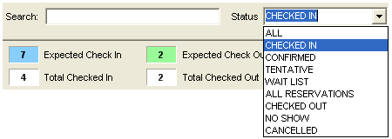
  - In the Guest List window, select the status of the guest to be searched for from the Status list.

Figure III-16

  - Type the guest’s name to be searched in the Search box then hit Enter key on the keyboard.
Figure III-17
  - If found, the row that matches the guest you have searched for will be highlighted with blue.
Figure III-18
Note: System will prompt you to continue searching for the guest in another status if the guest is not found under the status you specified.

? How to Make a Reservation in the Guest List window

- In the Guest List window, click on the New Reservation button. This will launch the Reservation window.

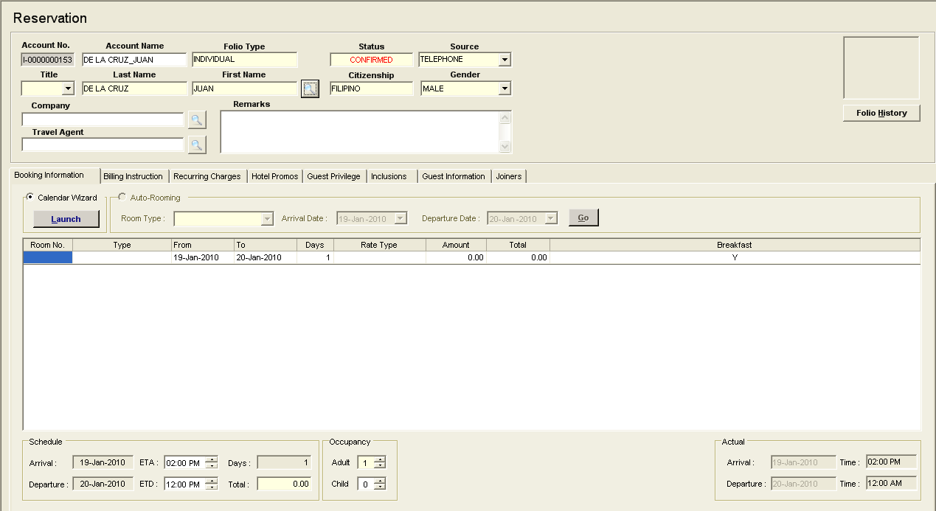

Figure III-19
- In the Reservation window, enter necessary details of the reservation.
- Click on the Save button.
Upon closing the window, system will direct the user to the Guest List window to show the newly added reservation.
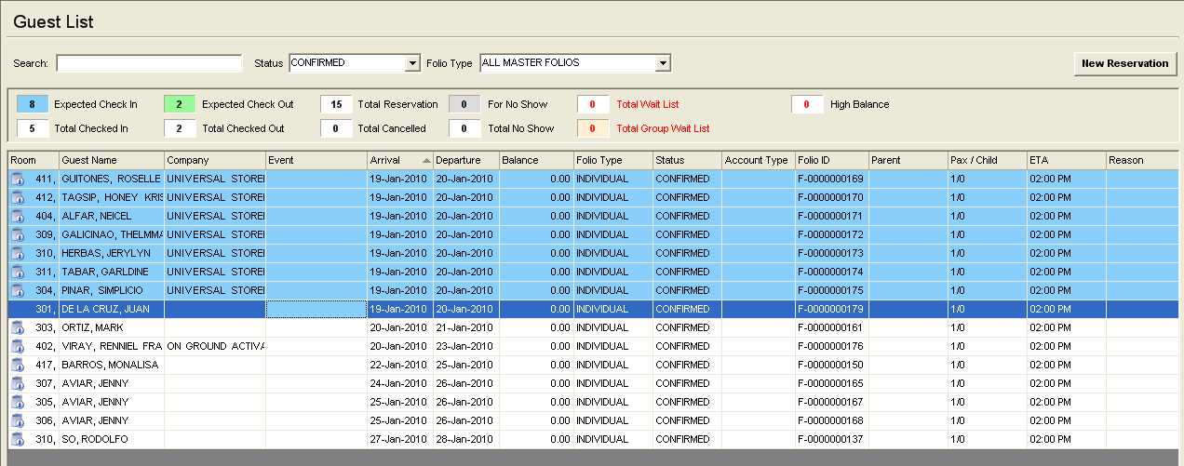

Figure III-20
4. Click on Cancel button to discontinue adding a new reservation.

? How to Cancel Reservation in the Guest List Window

- In the Guest List window, click on the guest whose reservation will be canceled from the list and left or right click on the guest and select Cancel Reservation.
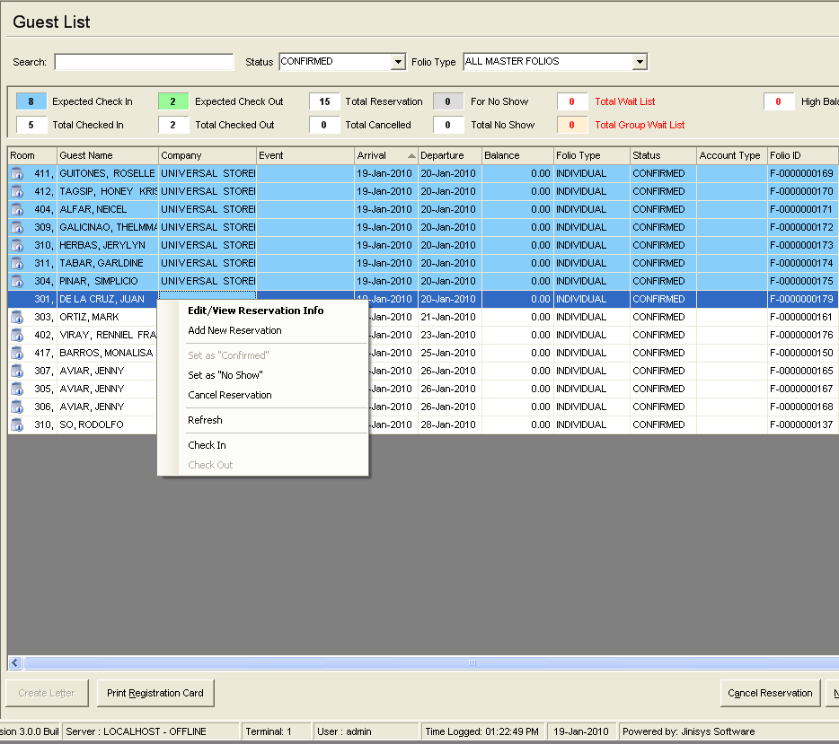
Cancel Reservation

Figure III-21
- The Reason window will be displayed as. Input the reason for canceling then click on OK button.
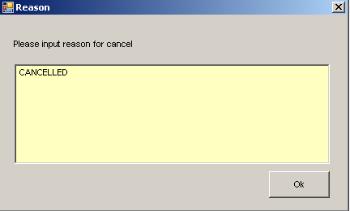

Figure III-22
- Click Yes when prompted if you are sure you want to cancel the reservation.
Click Ok when prompted that the reservation status was cancelled. The reservation will be seen under Canceled status list.
- Click on NO to discard the cancellation.
Do you know that …

You can easily identify the status of a guest by the color of its row. The color legends in the Guest Count box help you determine the status of guest, e.g.:
light blue – expected check-in, light green – expected check-out.

Under Checked In status:
You can view directly the Check Out window through the Check Out button.
You can create a letter for a guest through the Create Letter button.
You can print Registration Card of selected guest through the Print Registration Card button.

Under Confirmed status:
You can set a guest status to No Show through the No Show button.
You can directly Check-In a guest through the Check In button.

6. Folio Ledgers List – displays a summary of charges of all Checked-In Guests.
Location: Transactions -> Cashiering -> Folio Ledgers (F11)

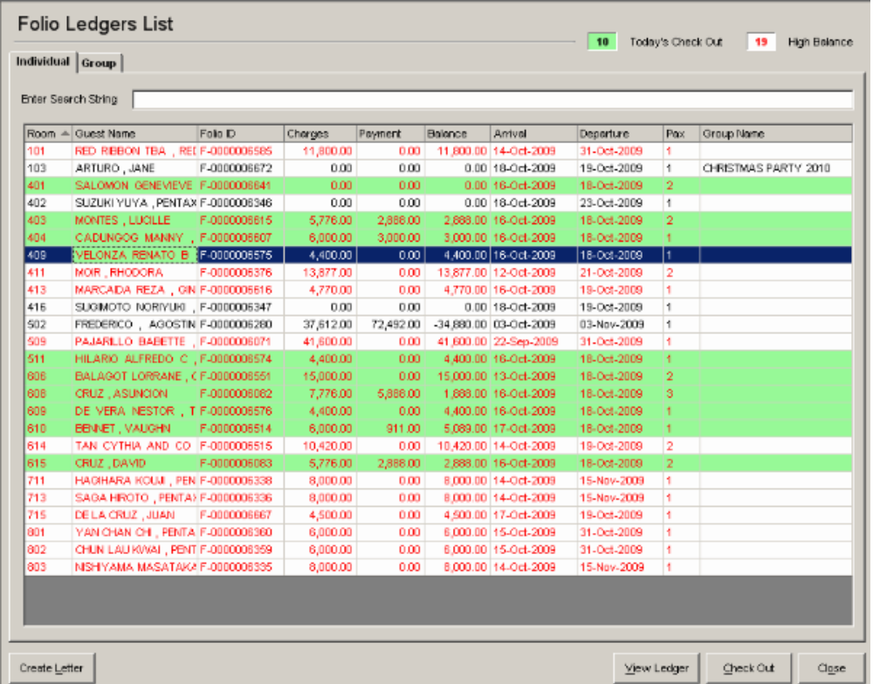
1
2
3
4
5
6
7
8

Figure III-23

- Individual Guests tab – displays a list of Individual Guest Accounts that are checked-in.
- Group Guests tab – displays a list of Group Accounts that are checked-in.
- Check-Out box – displays the total number of guests that are expected to check-out.
- High Balance box – displays the total number of guests that have reached the maximum allowable balance.
- Create Letter button – creates a letter for the selected high balanced guest.
- View Ledger button – displays the Folio Ledger of the selected Guest Account.
- Check Out button – opens the window for checking out a guest.
- Close button – closes the Folio Ledgers List window.

Do you know that…

Rows in yellow green are guests expected to check out on the current day while those in red have exceeded the maximum allowable balance.

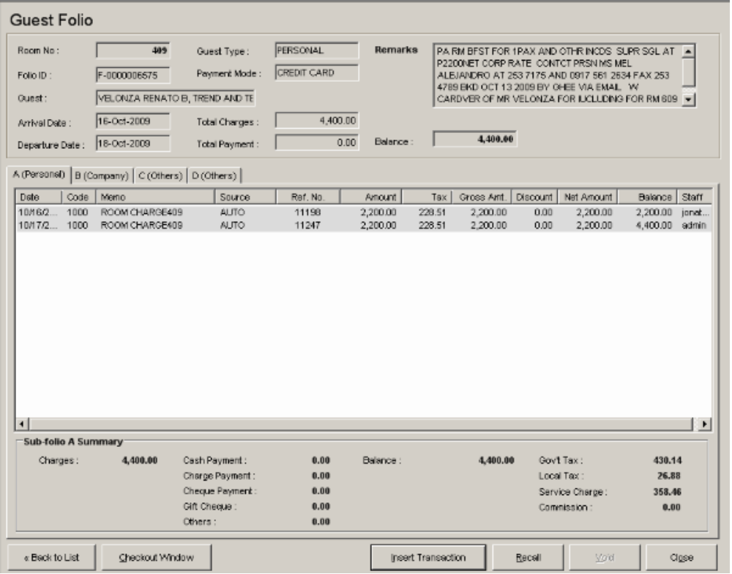
7. Folio Ledger – displays all transactions of a Guest Folio.
1
2
3
4
5
6
7
8
9

Figure III-24

- Folio Information box – displays the details of the folio including the total charges, payments and balances of all sub-folios.
- Sub-Folio tabs – displays all transactions (charges, payments) of the sub-folios.
- Sub-Folio Summary – displays the total charges and payments of a selected sub-folio.
- Back to List button – closes the Folio Ledger window and goes back to the Folio Ledgers List window.
- Checkout Window btn – closes the Folio Ledger window and opens the window for Check-Outs.
- Insert Transaction btn – opens the window for inserting transactions like payments and charges.
- Recall button – opens the window for recalling voided transactions.
- Void button – voids a selected transaction.
- Close button – closes the Folio Ledger window.

? How to INSERT a Transaction (Charge / Payment)
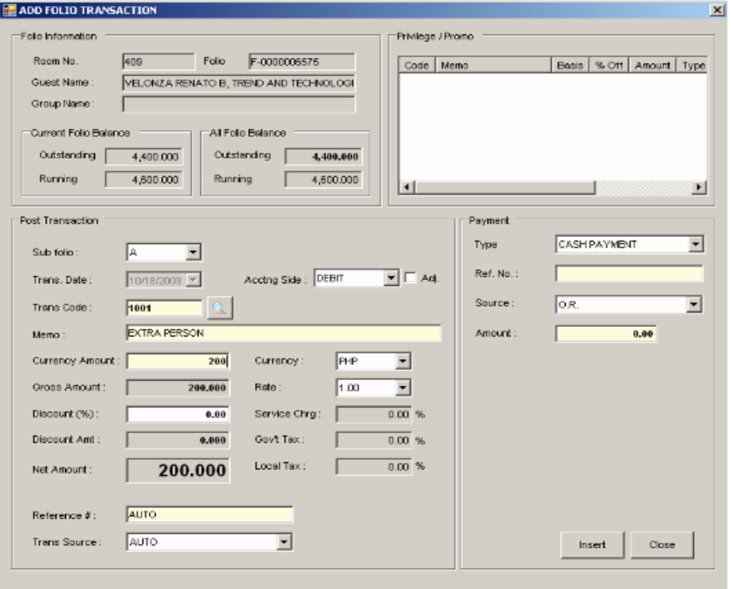

Figure III-25a
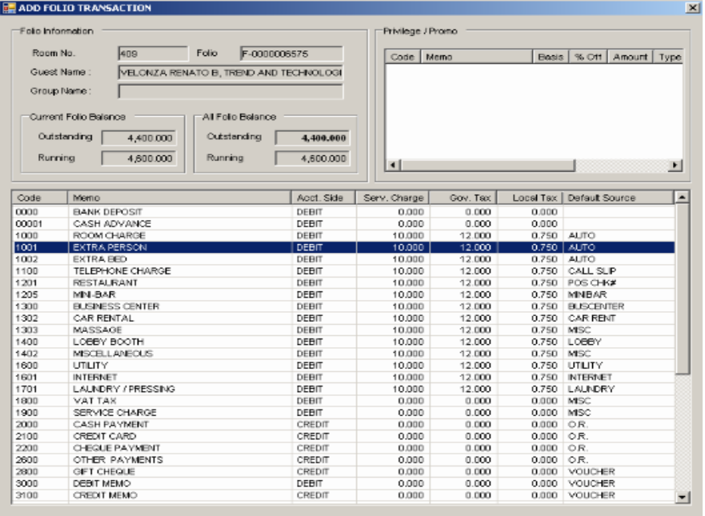

Figure III-25b
          - Click on the Insert Transaction button in the Add Transaction window (Figure III-25a).
          - Enter transaction automatically or manually:
? How to enter a transaction automatically
              - Type the transaction code on the Trans. Code field, and hit Enter key on the keyboard.

? How to enter a transaction manually
1. Click on the browse button to open the list of transactions (Figure III-25b).
2. Double-click the transaction from the list. The transactions list window will be closed.

          - Enter the currency amount, reference number, etc. If the transaction is a charge transaction and guest pays at once, input the payment details in the payment area.
          - Click on the Insert button.
The inserted transaction will be displayed on the specified sub-folio’s list of transactions.

? How to Void Transactions
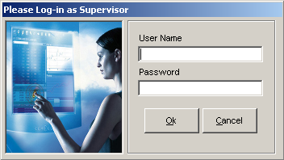

Figure III-26
- From the Folio Ledger window, select the transaction to be voided.
- Click on Yes when prompted if you are sure you want to void the transaction.
Log-in window will appear restricting the current user to perform the action. Only a supervisor or any executive personnel is given the privilege of voiding. As soon as the supervisor logs in, the transaction will be removed from the list and its status will be changed to “Void”.
- Click on “NO” button to discontinue voiding.

? How to Recall Voided Transactions
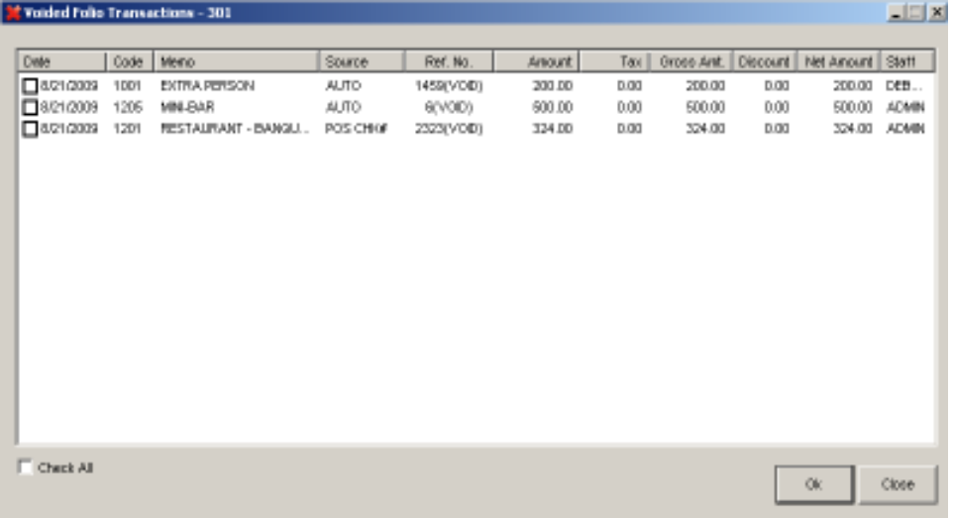

Figure III-27
          - From the Folio Ledger window, click on the Recall button.
The Voided Folio Transactions window will be shown. This contains a list of all the voided transactions.
          - Check the box of selected transaction that you want to recall.
          - Click the Ok button.
Transaction selected will be shown in the list of transactions in Guest Folio.
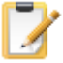
Do you know that…

Transactions highlighted in gray are transactions that are made on the previous days, and could not be voided since it is already posted to accounting.

? How to Transfer Debit/Credit
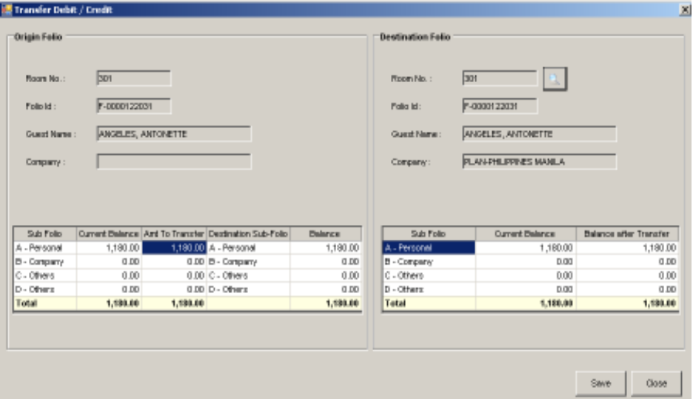

Figure III-28a
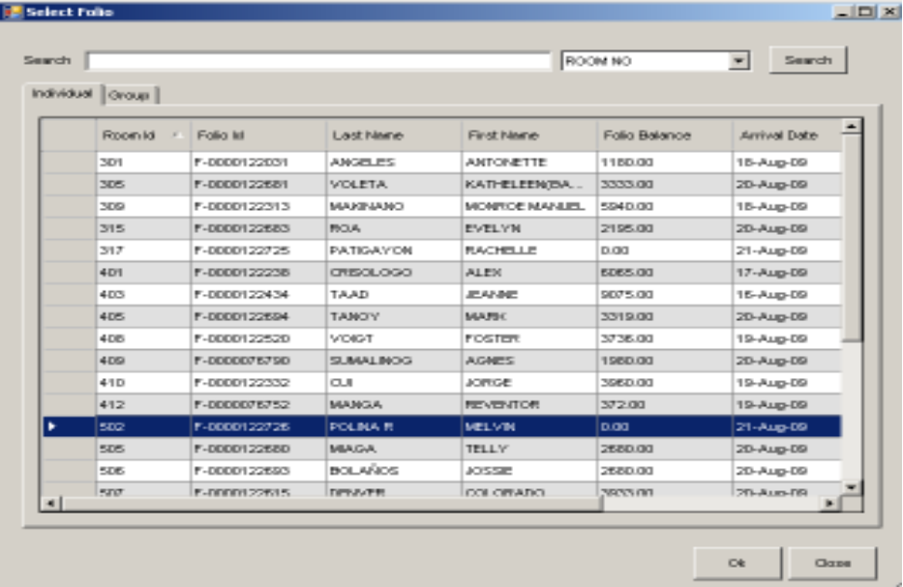

Figure III-28b
- From the Folio Ledger window, click on the Check out button. This opens the Check Out window.
- From the Check Out window, click on the Transfer Debit/Credit button. Transfer Debit/Credit window will appear.
- Click on the browse button from the Destination Folio section (Figure III-28a).
- From the list of all active folios that will open (Figure III-28b), select the folio where you want to transfer the amount. Then click Ok button. The current window will close.
- Enter the amount you want to transfer in the Amt. To Transfer column under Origin Folio. Then, select destination sub-folio in the next cell. This is where the amount being transferred will be posted.
- Click on the Save button.
- Click on Yes button when prompted if you are sure you want to continue.
Click Ok when prompted that the transaction was successful. System will return to Check Out window displaying the entry for folio transfer including the amount that you have just transferred. Also, the destination folio will be posted a folio transfer entry on it.
- Click on No button to discard the action.

8. Check Out Folio – checks out a folio.

? How to view the Check Out Window

From the Room Status Window
          - In the Room Status window, right click on the room to be checked out then click Check Out.
          - In the Folio Information window, click on the Check Out button.

From the Guest List Window
          - In the Guest List, click on the Check Out button.
          - In the Guest Folio, click on the Checkout Window button.
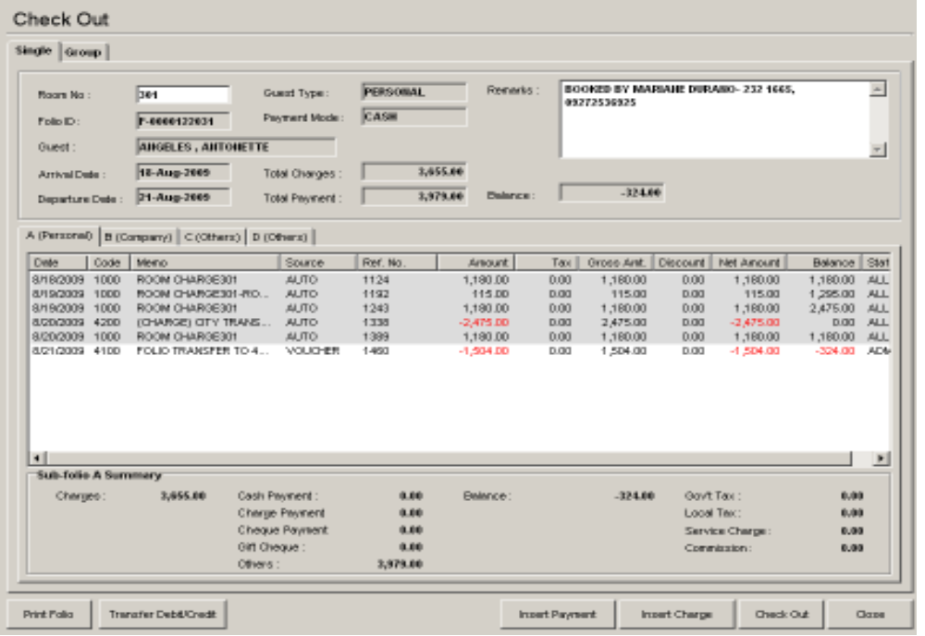
11
12
13
14
8
9
10
1
7
6
5
3
4
2

Figure III-29
- Folio Information box – displays the details of the folio including the total charges, payments and balances of all sub-folios.
- Remarks field – displays the additional notes of the guest made upon reservation.
- Total Charges field – displays total charges of all sub-folios.
- Total Payment field – displays total payments of all sub-folios.
- Balance field – displays total balance of all sub-folios. Negative sign denotes a refundable amount.
- Sub-Folio Transaction Details –displays all transactions (charges/payments) of a selected sub-folio.
- Sub-Folio Summary – displays the total charges and payments of a selected sub-folio.
- Sub-folio Balance – displays the total balance of the selected sub-folio.
- Print Folio button – prints a report for all transactions of the folio.
- Transfer Debit button – opens the Transfer Debit window that allows transferring of transactions to another folio or sub-folio.
- Insert Payment button – opens the Transaction window for payments.
- Insert Charge button – opens the window for inserting transactions
- Check Out button – updates the status of the folio to “Checked Out.”
- Close button – closes the Checkout window.

? How to Check Out a Folio

- Click on the “Check Out” button.
- If folio’s remaining balance is not zero, settle account first by inserting payments.
- If folio’s remaining balance is zero, a message will prompt you that check out is successful. Guest’s folio will be printed afterwards.
- Room status of the previously checked out folio will be updated to “Vacant Dirty.”

9. Transaction Routing - transfers transactions to another folio or sub-folio.
Location: Transactions -> Cashiering -> Route Transaction
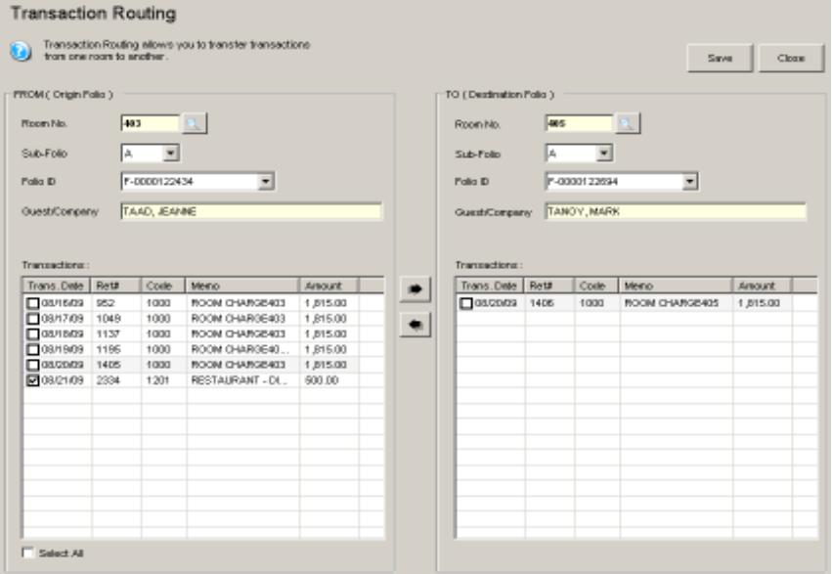

Figure III-30
? How to Route a Transaction

        - In the Origin Folio, input room number and hit enter key or click the browse button. A list of active Folios will be shown on the window (Figure III-28b). Do the same with the Destination Folio.
        - Under Origin Folio, select the sub-folio where the transaction to be routed is found. From the Transaction grid, check the box for the desired transaction (Figure III-30).
        - Under Destination Folio, select the sub-folio where the selected transaction from origin folio will be posted.
        - Click the arrow pointing to the right. Selected transaction will be moved to the destination folio.
Notes: The arrow pointing to the left will move the transaction back to the origin folio. Only the current day's transactions can be routed.
        - Once done, click Save button.
Do you know that…

Transaction Routing is useful when a transaction is posted to the wrong folio or sub-folio. It allows for the transfer of the transaction.

10. Direct Transaction Posting – allows posting of transactions without a folio account.
Location: Transactions -> Cashiering -> Direct Transaction Posting
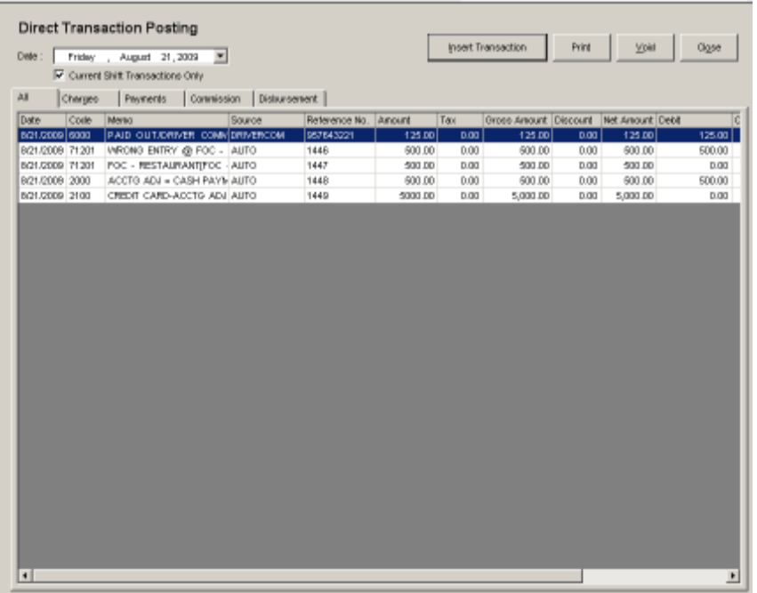
2
1
3
4
5
6
7
8
9
10
11

Figure III-31
        - Calendar date – displays calendar for date selection.
        - Current Shift Transactions Only box
  - option to display only the current shift’s transactions.
        - All tab – displays all transactions.
        - Charges tab – displays all charge transactions.
        - Payments tab – displays all payments.
        - Commission tab – displays all drivers’ commissions.
        - Disbursement tab – displays all disbursements made.
        - Insert Transaction button – inserts a transaction.
        - Print button – prints the selected transaction’s details.
        - Void button – voids the selected transaction.
        - Close button – closes Direct Transaction Posting window.

? How to INSERT Direct Charge and Payment transaction

            - Select Charges tab and click Insert Transaction button. Direct Transaction Post window will be shown (Figure III-32).
            - Enter Transaction code or click the browse button to select a transaction.
            - Enter currency amount, reference number, etc.
            - Insert payment details (Reference number and amount).
            - Once done, click Insert button.
Newly inserted transaction will be posted at Charges and Payments tab.
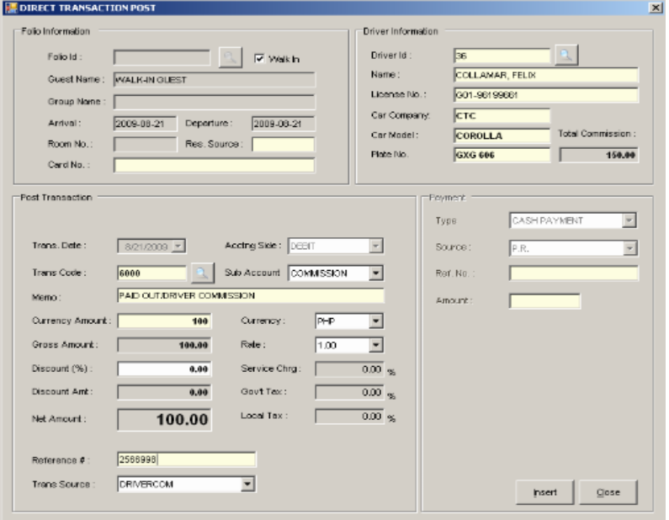

Figure III-32

? How to INSERT Commission
            - Select Commission tab, and click Insert Transaction button. The Direct Transaction Post window will open (Figure III-32).
            - Enter the Transaction code directly or click browse button and select “PAID OUT/DRIVER COMMISSION.”
            - Select Commission as sub-account.
            - Enter currency amount, reference number, etc.
            - In the Driver Information at the upper right corner, input the Driver ID or click browse button. A list of drivers will be shown at the screen (Figure III-33).
            - Select driver by double-clicking it, or by clicking it once and selecting OK button. System will return to Direct Transaction Post window.
            - Once done, click Insert.
Newly inserted transaction will be posted in the Commission tab.
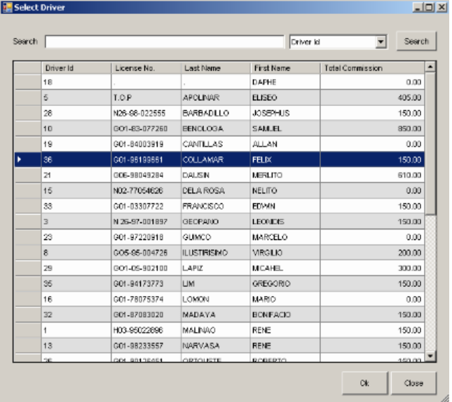

Figure III-33

? How to INSERT Disbursement

            - Select Disbursement tab, and click Insert Transaction button. Direct Transaction Post window will be shown.
            - Enter the Transaction code directly or click browse button and select “PAID OUT/DRIVER COMMISSION.”
            - Select Disbursement under sub-account.
            - Enter currency amount, reference number, transaction source. You may also edit the memo statement into a more detailed one.
            - Once done, click Insert button.
Newly inserted transaction will be posted in the Disbursement tab.

? How to Void a Direct Transaction

            - Select any transaction, and click Void button.
            - Selected transaction will be removed from the list.
Do you know that…

All payments under Payments tab are added to cashier sales directly; voided transaction amounts are subtracted automatically.

11. Opening / Closing Shift – allows user to open / close the shift for cashiering.
Location: Transactions -> Cashiering -> Open Shift / Cash Drawer
Location: Transactions -> Cashiering -> Close Shift / Cash Drawer

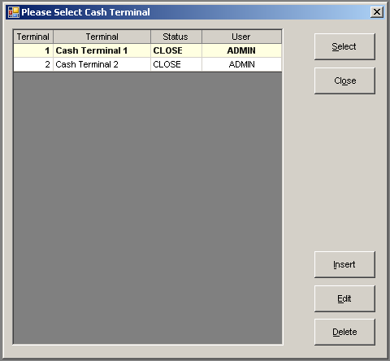

Figure III-34a

? How to Open Cash Drawer

- Open the Open Shift / Cash Drawer window.
- Select the Terminal of the cash drawer you want to open then click on the Select button. The Open Shift window will appear (Figure III-34b).
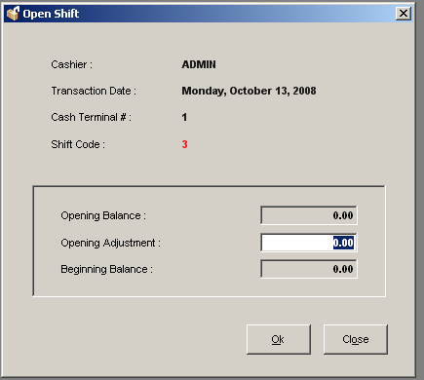

Figure III-34b

- Input the opening adjustment amount.
- Once done, click on the OK button. Cashier is now open for any transactions.
? How to Close Cash Drawer
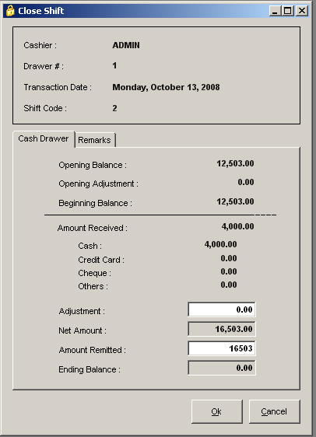

Figure III-35
- Open the Close Shift / Cash Drawer window.
- Provide the amount details and any remarks for the closing of shift.
- Once done, click on the Ok button. Shift will now be closed and reports for the closed cashier shift will be printed.

12. Day-End Closing – allows the user to execute the night audit operation.
Location: Transactions -> Night Audit -> Day-End Closing
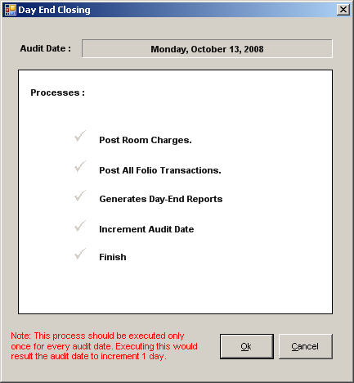

Figure III-36

? How to Process Night Audit

- Open the Day-End Closing window.
- Expected guest arrivals and departures should be cleared before proceeding with the night audit. If not, the user should cancel first all expected arrivals and settle all expected departures.
- Once ready, click on the Ok button.
- System will automatically post room charges and other transactions, and increment the date to the next day. Reports will also be generated after the operation.
Do you know that…

Night Audit automatically processes all room charges and other auto-posting transactions. It also increments the system date to 1 day, therefore this process should only be executed once in a day.

